Summary: Habitat Loss and System Capacity
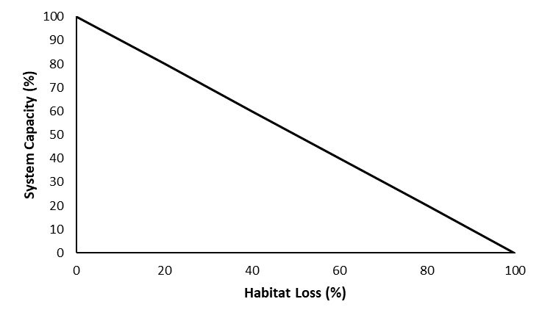

Stressor: Direct habitat loss

Response: System Capacity (%)

Species: Athabasca Rainbow Trout

(Oncorhynchus mykiss)

Life Stage: adult

System: Alberta foothills watersheds, excluding National Parks

Function Derivation: expert opinion

Transferability of Function: This function was developed and applied to Bull Trout, Athabasca Rainbow Trout, and Westslope Cutthroat Trout in Alberta foothills watersheds. The generality of this curve indicates that it could be safely applied to any species or system where proportion of direct habitat loss could be calculated.

Model Validation: Model not validated on independent data.

Detailed SR Function Description

Derivation of the function:
Habitat loss and degradation is often cited as a major impact and limiting factor for fish populations (e.g., native trout recovery plans). This stressor-response curve is exclusively meant to capture direct habitat loss. Direct habitat loss is defined as the removal of portions of a natural stream, or replacement of portions of a natural stream with a different landscape feature. For example, strip-mining for coal in parts of the native trout range has deleted some stream sections, or has resulted in the replacement of streams sections with open-pit lakes or with channeled stream analogs (i.e., a ditch) that do not provide trout habitat. The stressor-response curve for habitat loss is depicted by a linear relationship between the percentage of stream habitat lost and system capacity (Figure 1).

Source of stressor data to apply the function:

GIS-derived estimates of stream habitat lost or converted to different landscape features in the spatial unit of interest.

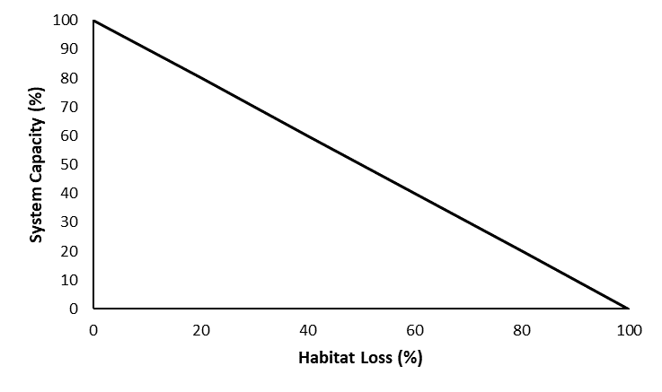
Stressor-Response Function
Figure 1: Relationship between direct habitat loss and the effect on the system capacity of the three species of native trout.

Stressor-Response Table
Table 1: Stressor response relationship between direct habitat loss and system capacity for Bull Trout, Athabasca Rainbow Trout, and Westslope Cutthroat Trout.
Percent Habitat Loss (%) | System Capacity (%) | SD | Lower Limit | Upper Limit
0 | 100 | 0 | 0 | 100
20 | 80 | 0 | 0 | 100
40 | 60 | 0 | 0 | 100
60 | 40 | 0 | 0 | 100
80 | 20 | 0 | 0 | 100
100 | 0 | 0 | 0 | 100

SR Function Confidence and Sources of Uncertainty
This uncertainty rubric was populated based on a summary report, not by the authors of the function with the original data. These rankings should be reassessed if additional information is available.
 | Low Confidence | Moderate Confidence | High Confidence
Data Source for SR Function |  |  | X
Rationale --> | The function was on direct conversion of habitat to non-fish bearing habitats.
Shape of SR Function |  |  | X
Rationale --> | The function is a direct 1:1 theoretical relationship.
Data Variance/  Consistency |  |  | X
Rationale --> | Variance around this function would exclusively be from measurement error.
Applicability to System |  |  | X
Rationale --> | This function is directly measured and applied to the species and system of interest.
Potential Stressor Interactions |  |  | X
Rationale --> | Although habitat loss can be correlated with downstream effects on population status, the conversion of fish-bearing habitat to non-fish bearing habitat is an irrefutable driver of local population abundance.

Recommended Citation
This document should be cited as:
Government of Alberta. 2024. Direct habitat loss stressor-response function for Athabasca Rainbow Trout, Westslope Cutthroat Trout, and Bull Trout. Environment and Protected Area Native Trout Cumulative Effects Model.

_____________________________________________________________________________________________

References

