Summary: Water Withdrawals during Low Flow Conditions and System Capacity
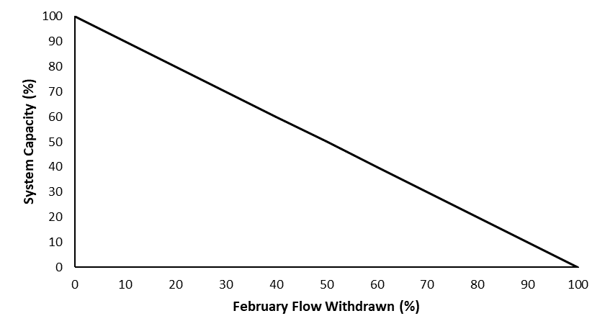

Stressor: Water Withdrawals during Low Flow

(percent withdrawn from natural

low flow conditions)

Response: System Capacity (%)

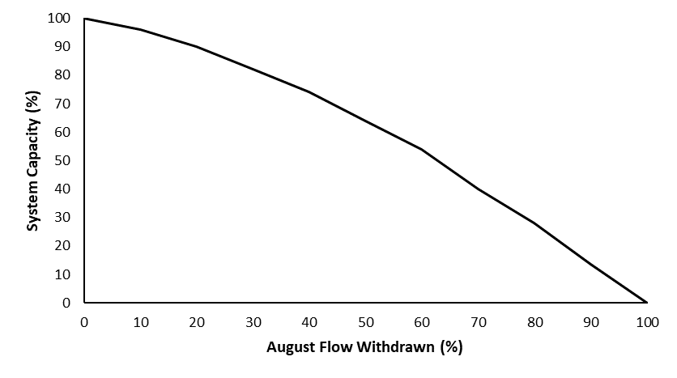
Species: Athabasca Rainbow Trout

(Oncorhynchus mykiss),

Bull Trout (Salvelinus confluentus),
Westslope Cutthroat Trout
(Oncorhynchus clarkii lewisi)

Life Stage: adult

System: Alberta foothills watersheds,

excluding National Parks

Function Derivation: theoretical relationships, landscape correlation

Transferability of Function: This function was applied to the three species for which it was developed (Bull Trout, Athabasca Rainbow Trout, and Westslope Cutthroat Trout). The function correlates environmental flow to habitat quantity through well-studied methods and broad landscape correlation, and thus could be applied to other salmonid species with caution.

Model Validation: Model not validated on independent data.

Detailed SR Function Description

Derivation of the function:

The effect of water withdrawals during February (winter) and August (summer) on the three native trout species was investigated using a multi-step analytical approach based on the low-flow habitat performance measures developed by Hatfield and Paul (2015). First, it was assumed there was a 1:1 relationship between the minimum available habitat (bottleneck effect) and the three trout species populations system capacity. To measure habitat, an index presented by Hatfield and Paul (2015) was used which: a) sets all flows >20% Mean Annual Discharge (MAD) to a habitat score of 1 (i.e., maximum suitability); b) has a habitat score of 0 at zero flow (i.e., no suitability); and, c) has a habitat score between 0 and 1 for flows between 0 and 20% MAD using a linear relation. This simple rating curve means that a flow of just under 20% MAD will score close to the maximum of 1, whereas a substantially lower flow will score proportionally less. The index was then used to determine the reduction in habitat scores from water withdrawals. Because withdrawals would have the greatest impact on the habitat score during low flows (i.e., < 20% MAD), percent withdrawal was determined for two periods of the year (August and February) and the lowest 10% of flows (i.e., Q90 or 90% exceedance flow) for these months. The approach was then applied to 37 rivers of varying size in Alberta that had year-round natural or naturalized (i.e., corrected for upstream water use) discharge and percent withdrawals ranging from 0–100% were modelled to assess the decrease in the habitat score from natural.
For February flow, all 37 rivers showed a similar linear response in the habitat score to water withdrawals. This average response was used as the basis for the stressor-response curve (Figure 1A). For August flows, the rivers showed a highly variable response in the habitat score to water withdrawals, ranging from linear (similar to February) to curvilinear with little initial response but increasing as withdrawals increased. The 75th percentile regression using a general additive model (Koenker 2017) was used to capture the curvilinear relationship (Figure 1B). The overall cumulative effects model only includes the season during which water withdrawals have the greatest effect on bull trout as physical habitat is assumed to limit populations by the minimum and not the combined product of February and August habitat.
As the Joe model accumulates cumulative effects multiplicatively (additive on a proportional scale), treating these two curves separately would inappropriately overemphasize the expected response. To overcome this issue, we treated February and August flow in the Joe model using a limiting factor approach. Simply, only the strongest, negative response from either the February and August stressor-response curves is used to calculate final system capacity. Anytime a watershed shows either February or August flow to be a hypothesized key driver, it must be acknowledged that the other stressor could be the driver given the collinearity.

Source of stressor data to apply the function:

The indicator used to measure the stressor in each watershed was the volume of water withdrawal divided by the natural low-flow discharge during February and August (percentage). This value was estimated using simple empirical relationships (Paul 2015, AEP, unpublished data) that relate mean annual discharge to the 90th exceedance flow (a measure of low flow) for either February or August and estimated water use derived from ALCES Online©.

Stressor-Response Function
A

B

Figure 1: Stressor-response curves depicting the expected relationship between changes in a) February and b) August flows and the system capacity of three species of native trout.

Stressor-Response Table

Table 1: The relationship between February flow withdrawal and system capacity.
February Flow Withdrawal (%) | System Capacity (%) | SD | Lower Limit | Upper Limit
0 | 100 | 0 | 0 | 100
10 | 90 | 0 | 0 | 100
20 | 80 | 0 | 0 | 100
30 | 70 | 0 | 0 | 100
40 | 60 | 0 | 0 | 100
50 | 50 | 0 | 0 | 100
60 | 40 | 0 | 0 | 100
70 | 30 | 0 | 0 | 100
80 | 20 | 0 | 0 | 100
90 | 10 | 0 | 0 | 100
100 | 0 | 0 | 0 | 100

Table 2: The relationship between August flow withdrawal and system capacity.
August Flow Withdrawal (%) | System Capacity (%) | SD | Lower Limit | Upper Limit
0 | 100 | 0 | 0 | 100
10 | 96 | 0 | 0 | 100
20 | 90 | 0 | 0 | 100
30 | 82 | 0 | 0 | 100
40 | 74 | 0 | 0 | 100
50 | 64 | 0 | 0 | 100
60 | 54 | 0 | 0 | 100
70 | 40 | 0 | 0 | 100
80 | 28 | 0 | 0 | 100
90 | 13.6 | 0 | 0 | 100
100 | 0 | 0 | 0 | 100

SR Function Confidence and Sources of Uncertainty
This uncertainty rubric was populated based on a summary report, not by the authors of the function with the original data. These rankings should be reassessed if additional information is available.
 | Low Confidence | Moderate Confidence | High Confidence
Data Source for SR Function |  | X
Rationale --> | Environmental flow needs for fish habitat have been extensively described in the literature (Hatfield & Paul 2015). The use of a 20% MAD threshold is well supported for a number of salmonids through peer-reviewed publications (Hatfield and Bruce 2000, Rosenfeld and Ptolemy 2012). These concepts were applied to 37 rivers in Alberta, which provided a broad test of the function against habitat scores.
Shape of SR Function |  | X
Rationale --> | The linear February flow withdrawal function is well-supported by the landscape data, but the August function showed substantial variation (linear or curvilinear).
Data Variance/  Consistency |  | X
Rationale --> | The shape of the August flow withdrawal curve varied substantially across the 37 watersheds, but February was more consistent.
Applicability to System |  |  | X
Rationale --> | The theory is well supported by peer-reviewed literature for application to salmonids. In addition, the habitat scores in the 37 watersheds used to build the function were for the three target species.
Potential Stressor Interactions |  | X
Rationale --> | There is potential for stressor interaction with temperature and sedimentation. As flows decrease and water quantity decreases, there may be additional effects such as changing temperature and sedimentation regimes. However, environmental flows are extensively studied and known to be a driving force in regulation of fish habitat quality and quantity.

Recommended Citation
This document should be cited as:
Government of Alberta. 2024. Surface water withdrawal stressor-response function for Athabasca Rainbow Trout, Westslope Cutthroat Trout, and Bull Trout. Environment and Protected Area Native Trout Cumulative Effects Model.

_____________________________________________________________________________________________

References

Hatfield, T., and J. Bruce. 2000. Predicting salmonid habitat–flow relationships for
streams from Western North America. North American Journal of Fisheries Management 20:1005-1015.
Hatfield, T., and A.J. Paul. 2015. A comparison of desktop hydrologic methods for determining environmental flows. Canadian Water Resources Journal 40:303-318.
Koenker, R. 2017. quantreg: Quantile Regression. R package version 5.33. https://CRAN.R-project.org/package=quantreg
Rosenfeld, J.S., and R. Ptolemy. 2012. Modelling available habitat versus available energy flux: do PHABSIM applications that neglect prey abundance underestimate optimal flows for juvenile salmonids? Canadian Journal of Fisheries and Aquatic Sciences 69(12):1920-1934.

