Summary: Direct Mortality and System Capacity

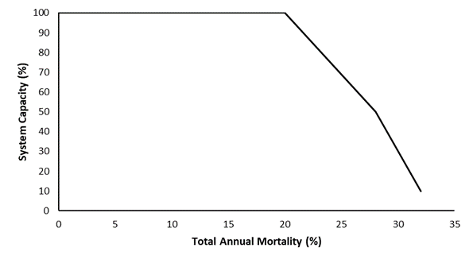
Stressor: Direct mortality (natural,
entrainment, research)

Response: System Capacity (%)

Species: Bull Trout

(Salvelinus confluentus)

Life Stage: adult

System: Alberta foothills watersheds, excluding National Parks

Function Derivation: mechanistic/theory-based relationships, empirical studies

Transferability of Function: This function was developed and applied to Bull Trout in Alberta foothills watersheds. Parameters used to derive inflection points are specific to Bull Trout on the Alberta east slopes, so it should be applied to other species with caution.

Model Validation: Model not validated on independent data.

Detailed SR Function Description

Derivation of the function:

In the Joe model, direct mortality was separated into natural causes, entrainment and research and monitoring, although more variables can be added as required. Using these three mortality sources, the total annual mortality rate (A) can be calculated using the conditional rates of natural mortality (n), entrainment mortality (en) and research and monitoring mortality (r), by applying the following equation adapted from Ricker (1975):

$$A=1-\left[\left(1-n\right)×\left(1-en\right)×\left(1-r\right)\right]$$

The stressor-response curve for direct mortality (Figure 1) is based on the results from modelling using a modified version of the Bull Trout model of Post et al. (2003). Assuming a conditional mortality rate of 20% from natural causes (Post et al. 2003), a Bull Trout population shown to switch from growth overfishing to recruitment overfishing (assumed to occur at ½ of maximum system capacity) if the combined conditional rate of mortality from other sources exceeded 8% and extirpation was expected when additional mortality exceeded 12% (Figure 1). Similar to the Angling Effort (incidental angling mortality and illegal harvest) function, there is an assumption that there is a portion of fish in a population that are less vulnerable or invulnerable to direct mortality hence the system capacity does not reach zero. For all three species, the upper limit of direct mortality was not exceeded so the stressor-response curve does not have a flat-tail on the x-axis but this could be seen in the future if the threat of entrainment or research and monitoring increase.

Source of stressor data to apply the function:

a. Entrainment Mortality
Fish can become entrained in irrigation canal headworks and killed if not rescued before the canal is dewatered at the end of the irrigation season. Entrainment rates are expected to be variable between canals, however, there have been no recent studies to determine the total number of entrained fish and the overall effect on population sustainability. The primary data source to inform the potential severity of this threat is the Trout Unlimited Canada annual fish rescue program, which includes most but not all canal headworks within the current Bull Trout and Westslope Cutthroat Trout range. Typically, no or small numbers of entrained Bull Trout (<10) and Westslope Cutthroat Trout (<5) are rescued (Lindsey et al. 2015); however, it should be noted that the rescues are not designed to estimate entrainment rates so these numbers should be viewed as minimum values only. In contrast, entrainment at the Belly River canal prior to screening to exclude large fish was estimated at 15 – 20% of annual mortality (Clayton 2001). The majority of canal headworks within Alberta's eastern slopes do not have fish exclusion devices.
Fish can also become entrained in powerhouses for hydroelectric reservoirs where a portion are killed as they pass through the turbines. Various aspects of Bull Trout entrainment in hydroelectric reservoirs have been widely studied in both the U.S. and British Columbia (B.C.) (Martins et al. 2013, Ma et al. 2012, Underwood and Kramer 2007, Salow and Hostettler 2004, and FERC 1995). Entrainment and mortality rates are highly site-specific, varying with physical factors including reservoir size, dam height, fore bay configuration, depth of intake, turbine type, and operational timing as well as biological factors including fish size, seasonal and diurnal movements and density-dependent influences on fish movement. While few generalizations can be made, entrainment rates of adult, sub-adult or juvenile Bull Trout can and do impact populations typically as annual losses (i.e., direct morality and permanent loss to downstream reaches) of <5%. For example: 1) Kinbasket Reservoir, B.C., adult Bull Trout - 3.4% loss (Martins et al. 2013); 2) Arrowrock Reservoir, ID, adult Bull Trout - 4% loss, 11% loss when drawn down for maintenance (Salow and Hostettler 2004), and 3) Rimrock Reservoir, WA, sub-adult Bull Trout - 1.4% loss (Underwood and Cramer 2007). Substantially greater mortality rates (9 – 42%, size dependent) are anticipated for the Peace/Halfway River Bull Trout population during the operation of the Site C Dam in B.C. (Ma et al. 2012). Higher entrainment rates have been recorded at the hydropower operation at the Aberfeldie Dam in British Columbia (Langford 2016).
For the Joe model, watersheds containing irrigation canal headworks were assigned an entrainment conditional mortality rate of 1% and those containing hydroelectric dams were assigned a rate of 4%, unless other data were available.

b. Research and Monitoring
Standard scientific methods for monitoring native trout populations typically involve the non-lethal capture, handling, and release of individual fish. Methods used to capture native trout include electrofishing, angling, trapping, and netting, with backpack and boat electrofishing being the most widely used in Alberta. After capture, fish are held for processing, often anesthetized, and measured. Depending on the project objectives, fish may also be marked (tagged), surgically implanted with telemetry transmitters, and/or have a small portion of a fin removed for genetic analysis. Lethal sampling of native trout is uncommon but may occur if information that cannot be collected using non-lethal means (e.g., maturity and age data) is required for management and assessment purposes. In these cases, the potential impacts on population sustainability are thoroughly reviewed by the appropriate regulatory agency(s) prior to project approval.
Alberta Fisheries Management has developed a series of standards including the Standard for the Ethical Use of Fish in Alberta (AESRD 2013a), Standard for Sampling Small Streams in Alberta (AESRD 2013b) and Electrofishing Policy Respecting Injuries to Fish (AFMD 2004) to minimize fish injury, stress and mortality during non-lethal collection and handling by research crews. These standards are included as conditions on Research Licences, which are mandatory licences issued to all agencies and organizations conducting fisheries-related work in the province. Research Licences also include a section detailing Best Management Practices relating to the processing of fish in cold and hot weather, proper handling techniques, and the use of anaesthetic. While the application of standards and best management practices does minimize fish injury, stress and mortality, some incidental mortality during fish collection and handling may occur. Incidental mortality is assumed to have negligible to very low population-level effects because the majority of native trout surveys are limited to small representative areas of a watershed and project time periods are typically short (1-5 years). Therefore, mortality due to scientific research and monitoring will not be included in the total annual mortality calculation unless there is evidence of a population-level impact within a particular watershed. Similarly, the U.S. Fish and Wildlife Service analyzed the effects of scientific research through a biological opinion survey (USFWS 2000) and determined that scientific collection does not jeopardize Bull Trout populations and is therefore not identified as a threat factor in the U.S. Bull Trout recovery plan (USFWS 2015). Nonetheless, this parameter is included in the model and the level of research and monitoring mortality is included in the calculations.
For the Joe model the conditional rate of mortality due to research and monitoring was set to 0% unless other data were available. Values will be adjusted if new information becomes available suggesting otherwise.

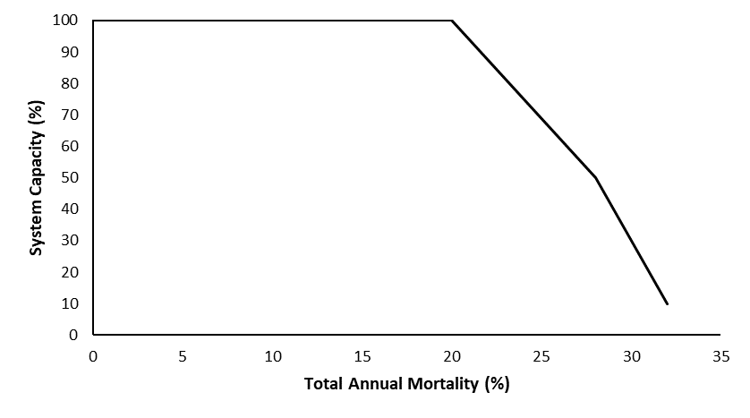
Stressor-Response Function
Figure 1: Stressor-response curve depicting the expected relationship between total annual mortality and the system capacity of Bull Trout populations.
Stressor-Response Table
Table 1: Stressor response relationship reflecting total annual mortality (as a function of natural, entrainment, and research mortality) within a watershed and the system capacity of Bull Trout populations.
Total Annual Mortality (%) |  | System Capacity (%) | SD |  | Lower Limit |  | Upper Limit
0 | 100 |  |  | 0 |  | 0 |  | 100
0.2 | 100 |  |  | 0 |  | 0 |  | 100
0.28 | 50 |  |  | 0 |  | 0 |  | 100
0.32 | 10 |  |  | 0 |  | 0 |  | 100

SR Function Confidence and Sources of Uncertainty
This uncertainty rubric was populated based on a summary report, not by the authors of the function with the original data. These rankings should be reassessed if additional information is available.
 | Low Confidence | Moderate Confidence | High Confidence
Data Source for SR Function |  |  | X
Rationale --> | The function was based on a peer-reviewed population model (Post et al 2003) that was parameterized with data from target populations of Bull Trout. These parameters were used to estimate the effect of total annual mortality on system capacity.
Shape of SR Function |  | X
Rationale --> | The function is divided into segments that are well-supported by fisheries population dynamic theory (Ricker 1975). The inflection points are based on parameter estimates from local populations.
Data Variance/  Consistency | X
Rationale --> | Variance around this function is largely unknown.
Applicability to System |  |  | X
Rationale --> | This function was based directly on mechanistic theory of Bull Trout on Alberta’s east slopes and on generalizable population dynamic theory.
Potential Stressor Interactions |  |  | X
Rationale --> | There is low potential for stressor interactions, as this function is based on mechanistic theory of the individual sources of mortality.

Recommended Citation
This document should be cited as:
Government of Alberta. 2024. Direct mortality (natural, entrainment, and research) stressor-response function for Bull Trout. Environment and Protected Area Native Trout Cumulative Effects Model.

_____________________________________________________________________________________________

References

AESRD - Alberta Environment and Sustainable Resource Development. 2013a. Standards for the ethical use of fishes in Alberta. 5 p.
AESRD - Alberta Environment and Sustainable Resource Development. 2013b. Standard for sampling of small streams in Alberta. 18 p.
AFMD - Alberta Fisheries Management Division. 2004. Electrofishing Policy Respecting Injuries to Fish. 3 p.
Clayton, T.B. 2001. Movements and status of Bull Trout (Salvelinus confluentus) in the Belly River, Alberta and Montana. Pages 141-145 in Brewin, M.K., A.J. Paul, and M. Monita, editors. Bull Trout II conference proceedings. Trout Unlimited Canada, Calgary, Alberta, Canada.
FERC - Federal Energy Regulatory Commission. 1995. Preliminary assessment of fish entrainment at hydropower projects, a report on studies and protective measures, volumes 1 and 2 (appendices). FERC Office of Hydropower Licensing, Washington, D.C. Paper No. DPR-10. June 1995 (volume 1) and December 1994 (volume 2).
Langford, M.T. 2016. Predicting the Hydraulic Influence of Hydropower Operations on Upstream Aquatic Habitat. A thesis submitted in partial fulfillment of the requirements for the degree of Doctor of Philosophy in Water Resources Engineering Department of Civil and Environmental Engineering. University of Alberta. 222 p.
Lindsay, E., L. Peterson, H. Tunna, J. Dubnyk, and T. Urquhart. 2015. Late Fall Fisheries Investigations in Irrigation Canals of Southern Alberta, 2014 Trout Unlimited Technical Report No. AB-037.
Ma, B., E. Parkinson, and D. Marmorek. 2012. Using single species population models of Bull Trout, Kokanee and Arctic Grayling to evaluate Site C passage alternatives. Site C Clean Energy Project Technical Data Report: Vol. 2, App. Q3, Attachment B.
Martins, E., L. Gutowsky, P. Harrison, D. Patterson, M. Power, D. Zhu, A. Leake, and S. Cooke. 2013. Forebay use and entrainment rates of resident adult fish in a large hydropower reservoir. Aquatic Biology 19: 253–263.
Post, J., C. Mushens, A. Paul, and M. Sullivan. 2003. Assessment of alternative harvest regulations for sustaining recreational fisheries: model development and application to Bull Trout. North American Journal of Fisheries Management 23:22–34.
Ricker, W.E. 1975. Computation and interpretation of biological statistics of fish populations. Bulletin of the Fisheries Research Board of Canada, Bulletin 191. Ottawa, ON. 401 pp.
Salow, T and L. Hostettler. 2004. Movement and mortality patterns of adult adfluvial Bull Trout (Salvelinus confluentus) in the Boise River basin Idaho. U.S. Bureau of Reclamation, Denver, Colorado.
Underwood, K., and S. Cramer. 2007. Simulation of human effects on Bull Trout population dynamics in Rimrock Reservoir, Washington. American Fisheries Society Symposium 53:191-207.
USFWS - U.S. Fish and Wildlife Service. 2000. Revised section 7 programmatic consultation on issuance of section 10(a)(1)(A) scientific take permits and section 6(c)(1) exemption from take for Bull Trout (Salvelinus confluentus) (6007.2100). Memorandum from Acting Supervisor, Snake River Basin Office, Boise, Idaho, to Regional Director, Region 1, Portland, Oregon. February 14, 2000. 22 p.
USFWS - U.S. Fish and Wildlife Service. 2015. Recovery plan for the coterminous United States population of Bull Trout (Salvelinus confluentus). Portland, Oregon. xii + 179 pages
Westslope Fisheries Ltd. 2012. BC Hydro Aberfeldie dam fish entrainment strategy Bull River fish entrainment – telemetry study. Prepared for BC Hydro. 94 pp.

