Summary: Fragmentation (Barrier Dams) and System Capacity

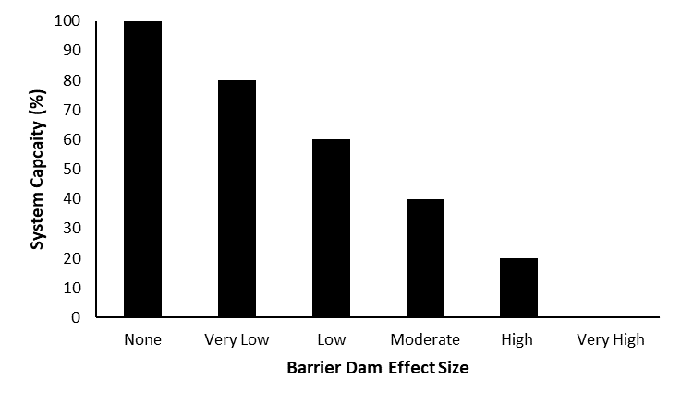
Stressor: Fragmentation

(large barrier dams)

Response: System Capacity (%)

Species: Bull Trout

(Salvelinus confluentus)

Life Stage: adult

System: Alberta foothills watersheds, excluding National Parks

Function Derivation: expert opinion

Transferability of Function: This function was developed and applied to Bull Trout, Athabasca Rainbow Trout, and Westslope Cutthroat Trout in Alberta foothills watersheds. While fragmentation due to large barrier dams has been shown to influence many aquatic systems, this function should be applied to other species and systems with caution.

Model Validation: Model not validated on independent data.

Detailed SR Function Description

Derivation of the function:

Dams can cause environmental changes such as alterations to water temperature, flow regime and sediment loading (Marmulla 2001). However, one of the most serious concerns for fish species is the fragmentation of connected riverine habitats, as dams that are not equipped with fish passage facilities can act as complete barriers to upstream and downstream fish movements (Marmulla 2001; GOA 2023, The Alberta Westslope Cutthroat Trout Recovery Team 2013). Many fish populations are likely sustained by metapopulation dynamics, where immigration from source populations ensures the persistence of surrounding subpopulations (Hanski 1998; Dunham and Rieman 1999). As a result, severing lotic connections may limit dispersal, and inhibit the recolonization of small, isolated populations that can be at increased risk of extinction through demographic, environmental and genetic stochasticity (Lande 1998; Morita et al. 2009). While literature has explored fragmentation of sturgeon habitat (Jager et al. 2001), fewer studies have evaluated the effects of dams on stream-dwelling salmonids. Of the available literature, Morita and Yokota (2002) found that extinction risk of White-Spotted Charr (Salvelinus leucomaenis) increased in small and isolated habitat fragments (Morita and Yamamoto 2002; Letcher et al. 2007). For cutthroat trout (Oncorhynchus clarkii), Harig and Fausch (2002) noted that population success upstream of barriers was strongly linked to available habitat area. Letcher et al. (2007) simulated fragmentation scenarios in a stream-resident Brook Trout (Salvelinus fontinalis) metapopulation and found that extinction was likely unless immigration from above barriers was possible or fish exhibited demographic life history changes.

In Alberta, it is difficult to quantify the effects of fragmentation due to large dams on the native trout species. The overall population level effect depends on a variety of factors such as patch size, habitat quality, and population size (Morita et al. 2009), as well as life history and behavioural traits (Letcher et al. 2007, Morita et al. 2009) and meta-population dynamics, and in most cases this information is not available for fish populations in the province. It is possible however, to provide a relative, qualitative estimate based on professional opinion considering available datasets. Several hypothetical situations will be described to elucidate this process. In the simplest case, if there are no dams in the system, then there is no effect. If a dam inhibits movement of migratory Bull Trout into a small portion of the lower watershed they once occasionally frequented (based on telemetry data), a low or very low effect size may be assigned. In contrast, a moderate effect would be assigned if the dam resulted in an isolated, trout population existing in a relatively small habitat patch, with no possible connections to other trout populations. Lastly, the severe decline or functional extirpation of migratory trout downstream of a dam soon after construction may indicate that suitable habitat to support all life history needs is no longer available (high to very high effect size). Until further information is available, the relationship between barrier dam effect size and sustainability of trout populations is assumed to be linear (Figure 1).

Source of stressor data to apply the function:

Qualitative estimate of barrier dam effect, based on expert opinion considering available data on trout movement, abundance, presence of life history type and change to trout populations before and after dam construction.

Stressor-Response Function
Figure 1: Stressor-response curve depicting the expected relationship between large barrier dams and the system capacity of the three species of native trout.

Stressor-Response Table
Table 1: Stressor response relationship between large barrier dams and system capacity for Bull Trout and Athabasca Rainbow Trout.
Barrier Dam Effect Size | System Capacity (%) | SD | Lower Limit | Upper Limit
0 | 100 | 0 | 0 | 100
1 | 80 | 0 | 0 | 100
2 | 60 | 0 | 0 | 100
3 | 40 | 0 | 0 | 100
4 | 20 | 0 | 0 | 100
5 | 0 | 0 | 0 | 100

SR Function Confidence and Sources of Uncertainty
This uncertainty rubric was populated based on a summary report, not by the authors of the function with the original data. These rankings should be reassessed if additional information is available.
 | Low Confidence | Moderate Confidence | High Confidence
Data Source for SR Function | X
Rationale --> | The function was based on expert opinion on broad, categorical responses to habitat fragmentation. Curve endpoints were largely theoretical.
Shape of SR Function | X
Rationale --> | The function is likely negative (supported by the literature) and assumed to be linear.
Data Variance/  Consistency | X
Rationale --> | Variance around this function is largely unknown.
Applicability to System | X
Rationale --> | This function was specifically based on hypotheses and theoretical responses of salmonids to barrier dams. Supporting literature focused on a range of species in different environments.
Potential Stressor Interactions |  | X
Rationale --> | As this is a hypothesized relationship based on metapopulation theory, the population response is likely driven by the primary stressor (barrier dams).

Recommended Citation
This document should be cited as:
Government of Alberta. 2024. Fragmentation (large barrier dams) stressor-response function for Athabasca Rainbow Trout, Westslope Cutthroat Trout, and Bull Trout. Environment and Protected Area Native Trout Cumulative Effects Model.

_____________________________________________________________________________________________

References

AWSCTRT, Alberta Westslope Cutthroat Trout Recovery Team. 2013. Alberta Westslope Cutthroat Trout Recovery Plan: 2012-2017. Alberta Environment and Sustainable Resources Development, Alberta Species at Risk Recovery Plan No. 28. Edmonton, AB. 77 pp.
Dunham, J.B. and B.E. Rieman. 1999. Metapopulation structure of bull trout: influence of physical, biotic, and geometrical landscape characteristics. Ecological Applications 9:642–655.
Government of Alberta (GOA). 2023. Alberta Bull Trout Recovery Plan. Alberta Species at Risk Recovery Plan No. 46. Edmonton, AB. 64 pp.
Hanski, I. 1998. Metapopulation dynamics. Nature 396:41-49.
Harig, A.L. and K.D. Fausch. 2002. Minimum habitat requirements for establishing cutthroat trout populations. North American Journal of Fisheries Management 12: 535–551.
Jager, H.I., J.A. Chandler, K.B. Lepla, and W.V. Winkle. 2001. A theoretical study of river fragmentation by dams and its effects on white sturgeon populations. Environmental Biology of Fishes 60:347-361.
Lande, R. 1998. Anthropogenic, ecological and genetic factors in extinction and conservation. Researches on Population Ecology 40:259–269.
Letcher, B.H., K.H. Nislow, J.A. Coombs, M.J. O’Donnell, and T.L. Dubreuil. 2007. Population response to habitat fragmentation in stream-dwelling brook trout population. PLoSONE 2:1-11.
Marmulla,G. 2001. Dams, fish and fisheries. Opportunities, challenges and conflict resolution. FAO Fisheries Technical Paper No. 419. 166 pp.
Morita K., S.H. Morita, and S. Yamamoto. 2009. Effects of habitat fragmentation by damming on salmonid fishes: lesson from white-spotted charr in Japan. Ecological Research 24:711-722.
Morita K., and S. Yamamoto. 2002. Effects of habitat fragmentation by damming on the persistence of stream-dwelling charr populations. Conservation Biology 16:1318–1323.
Morita K., and A. Yokota. 2002. Population viability of stream-resident salmonids after habitat fragmentation: a case study with white-spotted charr (Salvelinus leucomaenis) by an individual based model. Ecological Modelling 155:85-94.

