Summary: Natural Limitations and System Capacity

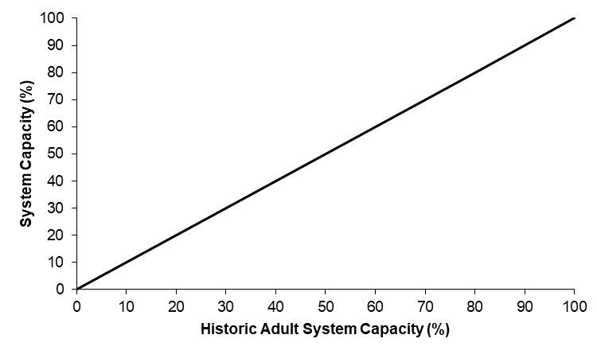
Stressor: Natural limitations (%),
as represented by Historical
Adult System Capacity (%)

Response: System Capacity (%)

Species: Bull Trout

(Salvelinus confluentus)

Life Stage: adult

System: Alberta foothills watersheds, excluding National Parks

Function Derivation: professional opinion

Transferability of Function: This function was developed and applied to Bull Trout, Athabasca Rainbow Trout, and Westslope Cutthroat Trout. Due to the generalizable nature of the 1:1 relationship, it could be applied anywhere where there is baseline data on the natural carrying capacity of the watershed.

Model Validation: Model not validated on independent data.

Detailed SR Function Description

Derivation of the function:

Native trout are naturally limited by other environmental variables besides water temperature. These limitations occur at varying spatial scales and include both biotic (e.g., productivity, fish community, etc.) and abiotic features (amount of woody debris, substrate composition, water velocity, groundwater input, natural sediment loads, natural flow regimes, etc.). Further, persistence in suitable, but isolated habitats may be limited if connectivity with neighbouring populations is naturally restricted and supplementation or re-colonization following local population decline or extirpation is not possible. These naturally limiting factors mean that a specific native trout population may never and would not be expected to achieve the reference system capacity of 100%, which is set using the most abundant, pristine native trout populations in the province. Understanding the influence of natural limitations on native trout populations today is difficult due to the confounding spatial and temporal effects of human disturbance and harvest. However, the relative status of native trout prior to extensive human disturbance and harvest (i.e., early 1900s) was assessed by the Historic Adult Density (HAD) FSA score, which will be used as a surrogate measure of natural limitations within each watershed in the species historic range. The HAD score is ranked from 1 (very low native trout density) to 5 (very high native trout density), but for this purpose was converted to a percentage-based natural limitations value. It was assumed there is a linear relationship between system capacity and natural limitations (Figure 1).

Source of stressor data to apply the function:

The natural limitations % was based on Historic Adult Density FSA score within the spatial unit of interest (i.e., HAD 1 = 10%, HAD 2 = 35%, HAD 3 = 60%, HAD 4 = 85%, and HAD 5 = 100%). There is no historic (i.e., >100 years) fisheries survey data; therefore, anecdotes, photographs, local environmental knowledge (LEK), traditional environmental knowledge (TEK) and information on fish barriers were used to inform HAD FSA scores. This included historical accounts from warden reports and angler interviews. Please note, these natural limitations rankings should only reflect limitations other than temperature.

Stressor-Response Function

Figure 1: Stressor-response curve depicting the expected relationship between natural limitations (as measured by historical adult percent system capacity) and the current system capacity of the three species of native trout.

Stressor-Response Table
Table 1: Stressor response function depicting the expected relationship between natural limitations (%HAD FSA) and the system capacity of the three species of native trout.
Natural Limitations (%) | System Capacity (%) | SD | Lower Limit | Upper Limit
0 | 0 | 0 | 0 | 100
20 | 20 | 0 | 0 | 100
40 | 40 | 0 | 0 | 100
60 | 60 | 0 | 0 | 100
80 | 80 | 0 | 0 | 100
100 | 100 | 0 | 0 | 100

SR Function Confidence and Sources of Uncertainty
This uncertainty rubric was populated based on a summary report, not by the authors of the function with the original data. These rankings should be reassessed if additional information is available.
 | Low Confidence | Moderate Confidence | High Confidence
Data Source for SR Function | X
Rationale --> | The function was based on the theoretical principle that natural (or pre-impact) limitations on carrying capacity would linearly affect current system capacity.
Shape of SR Function | X
Rationale --> | The shape of the function is theoretical.
Data Variance/  Consistency | X
Rationale --> | Variance around this function is largely unknown.
Applicability to System |  |  | X
Rationale --> | This function is broadly generalizable, and thus could be applied to any system.
Potential Stressor Interactions | X
Rationale --> | The authors attempted to limit the function to natural limitations other than temperature, but this is an assumption based on available data.

Recommended Citation
This document should be cited as:
Government of Alberta. 2024. Natural limitations stressor-response function for Bull Trout, Athabasca Rainbow Trout, and Westslope Cutthroat Trout. Environment and Protected Area Native Trout Cumulative Effects Model.

_____________________________________________________________________________________________

References

