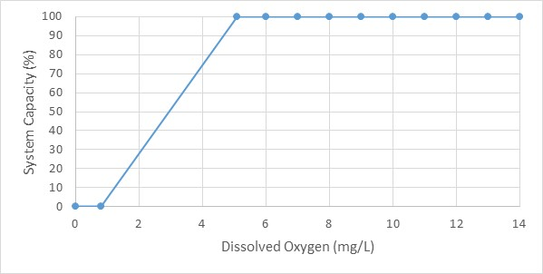
Summary: Dissolved Oxygen concentration and System Capacity for Nooksack Dace

Stressor: Dissolved Oxygen concentration (mg/L)

Response: System Capacity (%)

Species: Nooksack Dace (Rhinichthys cataractae)

Life Stage: Adult

System: Lower Fraser Valley, including the full distribution range of Nooksack Dace

Function Derivation: Empirical data from a generic meta-analysis of other species

Transferability of Function: As local adaptations are likely minimal among different Nooksack Dace populations, we would not expect much variation in true tolerance among populations. This function should therefore be broadly applicable to all populations of the species, with the caveat that it is based on generic data from other species.

Model Validation: The generic model is broadly consistent with known tolerance of DO for many species, with the significant caveat that many species have higher or lower tolerance than the average. The model has not been validated on independent data for Nooksack Dace because this data is absent.

Detailed SR Function Description:

Derivation of the function:

The effects of DO on system capacity was inferred based on a meta-analysis examining the effect of Dissolved Oxygen (DO) concentration on specific growth rate of fish, which evaluated data from 38 studies on 30 freshwater and marine species (Rosenfeld and Lee 2022). The shape of the curve and threshold value (5.1 mg/L) is based on segmented regression of specific growth rate as a function of dissolved oxygen averaged across 30 species. The inference implicit in using growth as the response variable is that threshold effects of low DO on individual growth will be similar to population-level effects. Although the average segmented regression across all species is highly significant and the threshold or 5.1 mg/L is consistent with previous analyses and regulatory guidelines for water quality, it should be noted that there remains great inter-specific variation around the mean response. Some species are relatively insensitive to hypoxia, particularly warmwater species, and others (particularly coolwater species and salmonids) showing higher sensitivity (see Fig. 1 below from Rosenfeld and Lee 2022).

We initially assumed that Nooksack dace would be relatively sensitive to low oxygen, as they are a riffle-dwelling species that occupy turbulent and well-oxygenated habitat. Consequently, our initial inference was to assign then the same sensitivity to reduced oxygen as salmonids, which have a relatively steeper decline in growth with reduced DO than the average for all species (Rosenfeld and Lee 2022, see Fig. 1b below). However, during sampling for fish in Aug. 2024 we made an observation which suggests that they are not as sensitive as salmonids. During a fish salvage in Pepin Creek, we placed 2 Nooksack dace in a 4l bucket along with one juvenile coho and 3 juvenile cutthroat trout (young-of-the-year). It was a warm day, and we inadvertently forgot about the bucket which was placed on the stream bank. When we checked up on it after an hour, the three yoy trout had asphyxiated, but the coho and the 2 dace were fine, and showed no sign of harm when held in the creek in a flow-through bin before release. This indicates that Nooksack dace are likely more tolerant of hypoxia than trout, despite being adapted to fast-water habitat, and we therefore used the average growth reduction vs. dissolved oxygen regression in Rosenfeld and Lee (2022; see their Fig. 1a below) as the stressor-response function for dissolved oxygen.
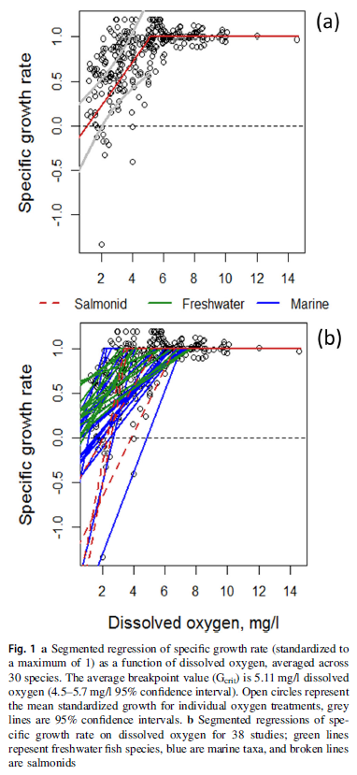

Source of stressor data to apply the function:

DO data is available for several reaches in Bertrand, Pepin, Fishtrap Creeks, and the Salmon River, collected as part of reconnaissance surveys to assess fish distribution, monitoring associated with habitat restoration, and mark–recapture population assessments that took place between 2003 and 2018. A predictive model to estimate DO as a function of temperature, flow, and associated covariates will need to be generated to create the dissolved oxygen stressor dataset

Stressor-Response Function

Figure 1: Stressor-response curve depicting the expected relationship between Dissolved Oxygen concentration (mg/L) and the system capacity of Nooksack Dace.
Stressor-Response Table
Table 1: Stressor response relationship reflecting Dissolved Oxygen concentration (mg/L) and the system capacity of Nooksack Dace populations.
Dissolved Oxygen (mg/L) | System Capacity (%) | SD | Lower Limit | Upper Limit
0 | 0 | 0 | 0 | 100
0.8 | 0 | 0 | 0 | 100
5.1 | 100 | 0 | 0 | 100
6 | 100 | 0 | 0 | 100
7 | 100 | 0 | 0 | 100
8 | 100 | 0 | 0 | 100
9 | 100 | 0 | 0 | 100
10 | 100 | 0 | 0 | 100
11 | 100 | 0 | 0 | 100
12 | 100 | 0 | 0 | 100
13 | 100 | 0 | 0 | 100
14 | 100 | 0 | 0 | 100

SR Function Confidence and Sources of Uncertainty
The uncertainty assessment below is based on our evaluation of the available data and level of confidence in the derived function. These rankings should be reassessed if additional information becomes available.
 | Low Confidence | Moderate Confidence | High Confidence
Data Source for SR Function |  | X
Rationale --> | This function is based on a generalized function for other fish species (freshwater, marine and salmonid) and therefore, moderately relevant to Nooksack Dace, unless they have atypical levels of hypoxia tolerance or sensitivity.
Shape of SR Function |  | X
Rationale --> | The general shape of the function is likely correct, but there is only moderate confidence in parameter estimates (threshold and intercept) as they are based on inferred relationships for other species.
Data Variance/  Consistency | X
Rationale --> | Variance around this function is largely unknown.
Applicability to System |  | X
Rationale --> | The target species is different from those in the data source, but the general location of the breakpoint and intercept are likely reasonable.
Potential Stressor Interactions |  |  | X
Rationale --> | Dissolved Oxygen concentration in the water is influenced by the water temperature, which also influence Nooksack Dace directly (due to thermal tolerance of the species and temperature effects on respiration). However, a stressor-response function has also been derived for effect of temperature on system capacity of Nooksack Dace.

Recommended Citation
This document should be cited as:
Usoof, A.M. and Rosenfeld, J.S. 2024. Relationship between system capacity and Dissolved Oxygen concentration for Nooksack Dace.
_____________________________________________________________________________________________

References
Hasnain SS, Minns CK, Shuter BJ (2010) Key ecological temperature metrics for Canadian freshwater fishes. Climate change research report CCRR-17. Ontario Ministry of Natural Resources, Sault Ste, Marie, Canada.
Lyons J, Zorn T, Stewart J et al. (2009) Defining and characterizing coolwater streams and their fish assemblages in Michigan and Wisconsin, USA. North Am J Fish Manag 9:1130–1151. https://doi.org/10.1577/m08-118.1
Rosenfeld, J., and Lee, R. 2022. Thresholds for Reduction in Fish Growth and Consumption Due to Hypoxia : Implications for Water Quality Guidelines to Protect Aquatic Life. Envirnmental Manag. Springer US. doi:10.1007/s00267-022-01678-9.

