# Summary: Percent Riffle in Reach and System Capacity for Nooksack Dace

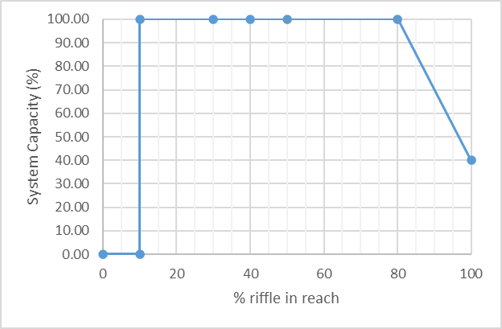

# Stressor**:** % riffle in reach

# Response: System Capacity (%)

# Species: Nooksack Dace (*Rhinichthys cataractae*)

# Life Stage: Adult

# System: Lower Fraser Valley, including the full distribution range of Nooksack Dace

# Function Derivation: Empirical data for Nooksack Dace from Bertrand Creek and for Longnose Dace from across North America

# Transferability of Function: As local adaptations are likely minimal among different Nooksack Dace populations, we would not expect much variation in true tolerance among populations. This function should therefore be broadly applicable to all populations of the species with caution.

# Model Validation: The model has not been validated on independent data for Nooksack Dace due to data unavailability.

# Detailed SR Function Description:

The shape and threshold for the final curve (10%) is based on Pearson et al. (2007) and Pearson (2004), which shows a large decline in percent reaches occupied by Nooksack Dace when percent riffle in reach in below 10%. The habitat suitability curve for Longnose Dace (Edwards et al. 1983) also supports the shape (a threshold response) of the function. The presumed ecological mechanism is that once riffle habitat declines below a minimum threshold (i.e., 10%) there is no longer sufficient habitat to support a large or continuous population, and riffles may be spatially isolated and unoccupied. based on expert opinion provided at the workshop held in November 2024, the originally proposed continuous declining response after threshold (10% riffle) was modified to a step response (Jordan Rosenfeld, Pers. Comm., 2024).

## Source of stressor data to apply the function:

# Percent riffle data is available for most (but not all) reaches in Bertrand, Pepin, Fishtrap Creeks, and the Salmon River, collected as part of Pearson (2004) and subsequent field work to define critical habitat for Nooksack dace.

# Stressor-Response Function

**Figure 1:** Stressor-response curve depicting the expected relationship between Percent Riffle in Reach and the system capacity of Nooksack Dace.

Stressor-Response Table

**Table 1:** Stressor response relationship reflecting Dissolved Oxygen concentration (mg/L) and the system capacity of Nooksack Dace populations.

|  |  |  |  |  |
| --- | --- | --- | --- | --- |
| **Percent Riffle in Reach** | **System Capacity (%)** | **SD** | **Lower Limit** | **Upper Limit** |
| 0.00 | 0.00 | 0 | 0 | 100 |
| 10.00 | 100.00 | 0 | 0 | 100 |
| 20.00 | 100.00 | 0 | 0 | 100 |
| 30.00 | 100.00 | 0 | 0 | 100 |
| 40.00 | 100.00 | 0 | 0 | 100 |
| 50.00 | 100.00 | 0 | 0 | 100 |
| 80.00 | 100.00 | 0 | 0 | 100 |
| 100.00 | 40.00 | 0 | 0 | 100 |

# SR Function Confidence and Sources of Uncertainty

The uncertainty assessment below is based on our evaluation of the available data and level of confidence in the derived function. These rankings should be reassessed if additional information becomes available.

|  |  |  |  |
| --- | --- | --- | --- |
|  | **Low Confidence** | **Moderate Confidence** | **High Confidence** |
| **Data Source for SR Function** |  |  | **X** |
| Rationale --> | This function is based on data for Nooksack Dace from target system. | | |
| **Shape of SR Function** |  |  | **X** |
| Rationale --> | The relationship has been established for the target species and system based on empirical data. | | |
| **Data Variance/**  **Consistency** |  | **X** |  |
| Rationale --> | Variance around this function is unknown, but the patterns appears fairly consistent for both Nooksack dace and Longnose dace. | | |
| **Applicability to System** |  |  | **X** |
| Rationale --> | Data from the target system (same species, populations and geographic area) was used to generate the function. | | |
| **Potential Stressor Interactions** |  |  | **X** |
| Rationale --> | Percent riffle in a reach can influence temperature (shallow water may warm more quickly), and Dissolved Oxygen concentration in the water (riffles are sites of re-aeration), which both influence Nooksack Dace physiology. However, separate stressor-response functions have been derived for the effects of temperature and Dissolved Oxygen concentration on system capacity for Nooksack Dace. In addition, substrate type may also be correlated with percent riffle, since both increase with higher gradient, and both influence system capacity. However, substrate size may also act independently of percent riffle, because riffles that are primarily gravel have lower abundance of Nooksack dace. Nevertheless, a separate stressor-response function has been derived for the effect of cobble substrate cover. | | |

# Recommended Citation

This document should be cited as:

Usoof, A.M. and Rosenfeld, J.S. 2024. Relationship between system capacity and Percent Riffle in Reach for Nooksack Dace.

**_____________________________________________________________________________________________**

# References

Edwards, E. A., H. Li, and C. B. Schreck. 1983. Habitat Suitability Index Models: Longnose Dace. U.S. Dept. Int., FishWildl. Serv. FWS/OBS-82/10.33.

Pearson, M. P. 2004. The ecology, status and recovery prospects of Noonsack dace (Rhinichthys Cataractae ssp.) and Salish sucker (Catostomus sp.) in Canada. University of British Columbia.

Pearson, M. P., T. Hatfield, J. D. McPhail, J. S. Richardson, J. S. Rosenfeld, H. Schreier, D. Schluter, D. J. Sneep, M. Stejpovic, E. B. Taylor, and P. M. Wood. 2007. Recovery Strategy for the Nooksack Dace ( Rhinichthys cataractae) in Canada. Species at. Fisheries and Oceans Canada, Vancouver B.C.