# Summary: Dissolved Oxygen concentration and System Capacity for Salish Sucker

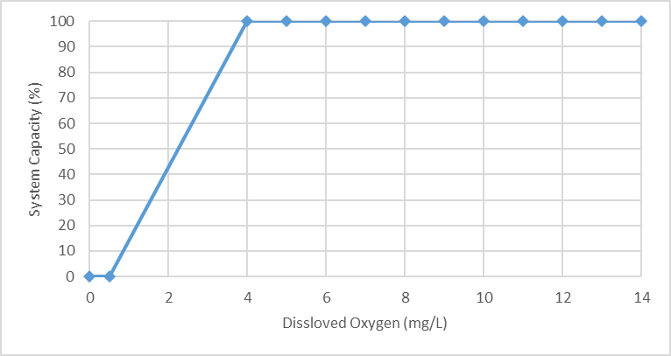

# Stressor**:** Dissolved Oxygen concentration (mg/L)

# Response: System Capacity (%)

# Species: Salish Sucker (*Catostomus sp.*)

# Life Stage: Adult

# System: Lower Fraser Valley, including the full distribution range of Salish Sucker

# Function Derivation: Empirical data from a generic meta-analysis of other species

# Transferability of Function: As local adaptations are likely minimal among different Salish Sucker populations, we would not expect much variation in true tolerance among populations. This function should therefore be broadly applicable to all populations of the species, with the caveat that it is partly based on data from other related species.

# Model Validation: The generic model is broadly consistent with known tolerance of DO for many species, with the significant caveat that many species have higher or lower tolerance than the average. The model has not been validated on independent data for Salish Sucker (i.e. data independent from earlier analyses used to infer the relationship).

# Detailed SR Function Description:

## 

## Derivation of the function:

## The effects of DO on system capacity was mainly inferred based on a meta-analysis examining the effect of Dissolved Oxygen (DO) concentration on specific growth rate of fish, which evaluated data from 38 studies on 30 freshwater and marine species (Rosenfeld and Lee 2022). The shape of the curve and threshold value (5.1 mg/L) is based on segmented regression of specific growth rate as a function of dissolved oxygen averaged across 30 species. The inference implicit in using growth as the response variable is that threshold effects of low DO on ***individual*** growth will be similar to ***population-level*** effects. Although the average segmented regression across all species is highly significant and the threshold or 5.1 mg/L is consistent with previous analyses and regulatory guidelines for water quality, there remains great inter-specific variation around the mean response. Salish sucker is not a cold-water species and therefore, less sensitive to hypoxia compared to salmonids (Rosenfeld et al. 2021; Zinn et al. 2021). Based on observation and experience, and the assumption that Salish sucker are selected for some degree of hypoxia tolerance because they have evolved in small streams subject to seasonal drying and low flows (and also prefer deep pool or wetland habitat that is subject to intermittent hypoxia), the threshold DO for sublethal effects on Salish sucker has been set at 4 mg/L (Fisheries and Oceans Canada 2019). We set the x-intercept at 0.5 mg/L to reflect the higher known tolerance of Salish sucker compared to salmonids (x-intercept ≈ 3 mg/L) and the average across all species (0.8 mg/l DO; Rosenfeld et al. 2021, Rosenfeld and Lee 2022). The habitat suitability index model for Longnose Sucker (Edwards, 1983) generally supports the shape of the function, but has a higher threshold (6 mg/L) and x-intercept (4.5 mg/L), reflecting the fact that Longnose sucker (the sister-species to Salish sucker) are a cool-water species.

## Source of stressor data to apply the function:

# DO data is available for several reaches in Bertrand, Pepin, Fishtrap Creeks, and the Salmon River, collected as part of reconnaissance surveys to assess fish distribution, monitoring associated with habitat restoration, and mark–recapture population assessments that took place between 2003 and 2018. A predictive model to estimate DO as a function of temperature, flow, and associated covariates will need to be generated to create the dissolved oxygen stressor dataset.

# Stressor-Response Function



**Figure 1:** Stressor-response curve depicting the expected relationship between Dissolved Oxygen concentration (mg/L) and the system capacity of Salish Sucker.

Stressor-Response Table

**Table 1:** Stressor response relationship between Dissolved Oxygen concentration (mg/L) and the system capacity of Salish Sucker populations.

|  |  |  |  |  |
| --- | --- | --- | --- | --- |
| **Dissolved Oxygen (mg/L)** | **System Capacity (%)** | **SD** | **Lower Limit** | **Upper Limit** |
| 0 | 0 | 0 | 0 | 100 |
| 0.5 | 0 | 0 | 0 | 100 |
| 4 | 100 | 0 | 0 | 100 |
| 5 | 100 | 0 | 0 | 100 |
| 6 | 100 | 0 | 0 | 100 |
| 7 | 100 | 0 | 0 | 100 |
| 8 | 100 | 0 | 0 | 100 |
| 9 | 100 | 0 | 0 | 100 |
| 10 | 100 | 0 | 0 | 100 |
| 11 | 100 | 0 | 0 | 100 |
| 12 | 100 | 0 | 0 | 100 |
| 13 | 100 | 0 | 0 | 100 |
| 14 | 100 | 0 | 0 | 100 |

# SR Function Confidence and Sources of Uncertainty

The uncertainty assessment below is based on our evaluation of the available data and level of confidence in the derived function. These rankings should be reassessed if additional information becomes available.

|  |  |  |  |
| --- | --- | --- | --- |
|  | **Low Confidence** | **Moderate Confidence** | **High Confidence** |
| **Data Source for SR Function** |  | **X** |  |
| Rationale --> | The shape of the function is based on a generic data regression for other fish species (freshwater, marine and salmonid), but the thresholds have been modified based on observational data for Salish sucker. | | |
| **Shape of SR Function** |  | **X** |  |
| Rationale --> | The general shape of the function and threshold are supported by data. However, the x-intercept is inferred based on the observation that Salish sucker is less sensitive to hypoxia than salmonid species, and likely the average generic curve for most species. | | |
| **Data Variance/**  **Consistency** | **X** |  |  |
| Rationale --> | Variance around this function for Salish sucker is unclear. | | |
| **Applicability to System** |  | **X** |  |
| Rationale --> | For the shape of the function, the target species is different from those used to generate the generic SR function. On the other hand, data used to infer the thresholds for SS include the target system (same species, populations and geographic area). | | |
| **Potential Stressor Interactions** |  |  | **X** |
| Rationale --> | Dissolved Oxygen concentration in the water is influenced by the water temperature, which also influence Salish Sucker directly (due to thermal tolerance of the species and temperature effects on respiration). However, a stressor-response function has also been derived for effect of temperature on system capacity of Salish sucker, and the two can be treated as independent. There is also a correlative interaction between temperature and DO (where DO declines with temperature), but this is captured (or should be) in the stressor magnitude data. | | |

# Recommended Citation

This document should be cited as:

Usoof, A.M. and Rosenfeld, J.S. 2024. Relationship between system capacity and Dissolved Oxygen concentration for Nooksack Dace.

**_____________________________________________________________________________________________**

# References

Fisheries and Oceans Canada. 2019. Recovery strategy for the Salish Sucker ( Catostomus sp .) in Canada [Proposed]. 1st amendment. Species at Risk Act Recovery Strategy Series. Fisheries and Oceans Canada, Ottawa. vii - 78 pp.

Rosenfeld, J., and Lee, R. 2022. Thresholds for Reduction in Fish Growth and Consumption Due to Hypoxia: Implications for Water Quality Guidelines to Protect Aquatic Life. Envirnmental Manag. Springer US. doi:10.1007/s00267-022-01678-9.

Rosenfeld, J., Pearson, M.P., Miners, J., and Zinn, K. 2021. Effects of landscape-scale hypoxia on Salish sucker and salmonid habitat associations : implications for endangered. **1233**(February): 1219–1233.

Zinn, K.R., Rosenfeld, J.S., and Taylor, E.B. 2021. Effects of experimental flow manipulations on water quality, hypoxia, and growth of threatened salish sucker (Catostomus sp. cf. catostomus) and juvenile coho salmon (oncorhynchus kisutch). Can. J. Fish. Aquat. Sci. **78**(9): 1234–1246. doi:10.1139/cjfas-2020-0135.