Summary: Water Depth and System Capacity for Salish Sucker

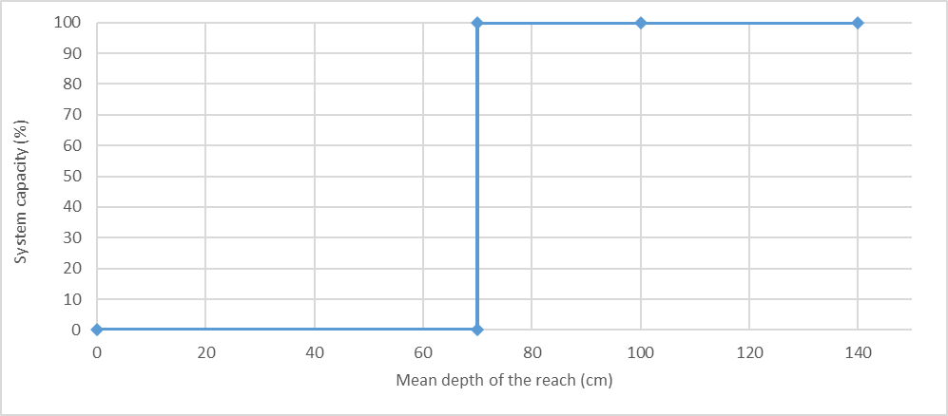
Stressor: Water Depth

(cm)

Response: System Capacity (%)

Species: Salish Sucker (Catostomus sp.)

Life Stage: Adult and Juvenile

System: Lower Fraser Valley, including the full distribution range of Salish Sucker

Function Derivation: Empirical data for Salish Sucker from lower Fraser Valley

Transferability of Function: As local adaptations are likely minimal among different Salish Sucker populations, we would not expect much variation in true tolerance among populations. This function should therefore be broadly applicable to all populations of the species, with the caveat that it is partly based on data from other related species.

Model Validation: Model is not validated on independent data for Salish Sucker due to unavailability of data.

Detailed SR Function Description:

We inferred a stepwise function with a threshold value of 70 cm based on the inference made in Pearson (2004) and Fisheries and Oceans Canada (2019). This is based on the inference from Fig 3.3 from Pearson (2004) pasted below (Figure 1) that Adult Salish sucker are generally most likely to be caught in habitats where the depth is greater than 70cm for at lest 50 contiguous meters (this is also the definition of critical habitat for Salish sucker. Edwards (1983) describes the relationship for lacustrine Longnose Dace (depth is in meters) and therefore, not applicable to Salish Sucker (Figure 2). However, it shows a sharp decline in habitat suitability at the threshold value and therefore, partly supports the shape of the final function.

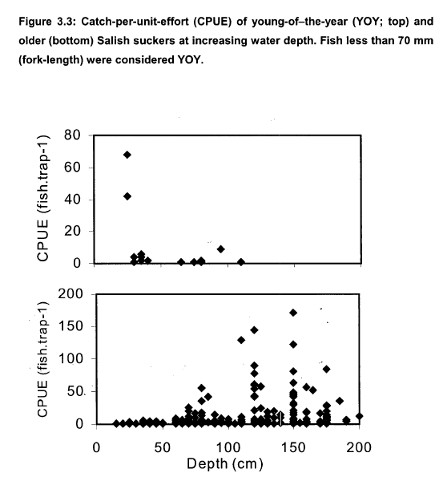
Figure 1. Relationship between water depth (cm) and CPUE of YOY (top) and adult (bottom) Salish Sucker (Pearson, 2004)
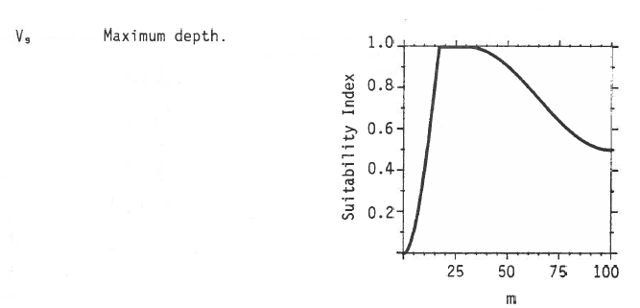

Figure 2. Relationship between depth (m) and habitat suitability index for lacustrine longnose sucker (Edwards 1983)

Source of stressor data to apply the function:

Data on length of reaches greater than 70cm deep is available for most (but not all) reaches in Bertrand, Pepin, Fishtrap Creeks, and the Salmon River, collected as part of Pearson (2004) and subsequent field work to define critical habitat for Salish sucker.

Note that this SR function will likely not be directly used to calculated cumulative effects in CEMPRA. Rather, the length or proportion of deep pool habitat meeting this criteria (i.e. the quantity of this specific critical habitat) will be treated as an input variable in the stressor magnitude table (see the matching SR function for proportion of deep pool habitat).

Stressor-Response Function

Figure 1: Stressor-response curve depicting the expected relationship between mean water depth (cm) and the system capacity of Salish Sucker.
Stressor-Response Table
Table 1: Stressor response relationship reflecting mean water depth (cm) and the system capacity of Salish Sucker populations.
Water depth (cm) | System Capacity (%) | SD | Lower Limit | Upper Limit
0.00 | 0 | 0 | 0 | 100
69.90 | 0 | 0 | 0 | 100
70.00 | 100 | 0 | 0 | 100
100.00 | 100 | 0 | 0 | 100
140.00 | 100 | 0 | 0 | 100

SR Function Confidence and Sources of Uncertainty
The uncertainty assessment below is based on our evaluation of the available data and level of confidence in the derived function. These rankings should be reassessed if additional information becomes available.

 | Low Confidence | Moderate Confidence | High Confidence
Data Source for SR Function |  |  | X
Rationale --> | This function is based on data for Salish Sucker from target system.
Shape of SR Function |  |  | X
Rationale --> | The relationship has been established for the target species and system based on empirical data.
Data Variance/  Consistency | X | X
Rationale --> | Variance around this function is likely considerable (see Fig 3.3 from Pearson (2004) above), but there can be fairly high confidence that adult sucker are not caught at high abundance in shallow water; and the threshold depth of ~70cm is likely reasonably robust).
Applicability to System |  |  | X
Rationale --> | Data from the target system (same species, populations and geographic area) was used to generate the function.
Potential Stressor Interactions |  |  | X
Rationale --> | Deep pool habitats are particularly vulnerable to hypoxic conditions (decline in Dissolved Oxygen concentration in the water), which also influence Salish Sucker directly (Rosenfeld et al. 2021). However, a stressor-response function has been derived for the effect of Dissolved Oxygen concentration on system capacity of Salish Sucker. Nevertheless, estimation of Dissolved Oxygen at the reach scale for populating the Stressor Magnitude file for CEMPRA modelling will need to account for habitat (i.e. deep pool) effects on hypoxia.

Recommended Citation
This document should be cited as:
Usoof, A.M. and Rosenfeld, J.S. 2024. Relationship between system capacity and mean water depth for Salish Sucker.
_____________________________________________________________________________________________

References
Edwards, E. A. 1983. Habitat Suitability Index Models: Longnose Sucker. U.S. Dept. Int., FishWildl. Serv. FWS/OBS-82/10.35.
Fisheries and Oceans Canada. 2019. Recovery strategy for the Salish Sucker ( Catostomus sp .) in Canada [Proposed]. 1st amendment. Species at Risk Act Recovery Strategy Series. Fisheries and Oceans Canada, Ottawa.
Pearson, M. P. 2004. The ecology, status and recovery prospects of Noonsack Dace (Rhinichthys Cataractae ssp.) and Salish Sucker (Catostomus sp.) in Canada. University of British Columbia.
Rosenfeld, J., M. P. Pearson, J. Miners, and K. Zinn. 2021. Effects of landscape-scale hypoxia on Salish sucker and salmonid habitat associations : implications for endangered 1233:1219–1233.

