# Summary: Fragmentation (Roads) and System Capacity

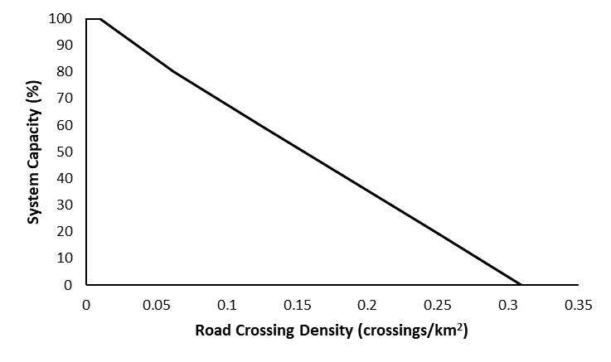

# Stressor: Fragmentation

# (road crossing density)

# Response: System Capacity (%)

# Species: Westslope Cutthroat Trout

# (*Oncorhynchus clarkii lewisi*)

# Life Stage: adult

# System: Alberta foothills watersheds, excluding National Parks

# Function Derivation: expert opinion, landscape correlation

# Transferability of Function: This function was developed and applied to Westslope Cutthroat Trout in Alberta foothills watersheds. Data on Bull Trout and Athabasca Rainbow Trout showed a slightly different relationship, so a separate function was used. While fragmentation due to road crossings has been shown to influence many aquatic systems, this function should be applied to other species and systems with caution.

# Model Validation: Model not validated on independent data.

# Detailed SR Function Description

Derivation of the function:

The three native trout species are migratory and require connectivity between key spawning, rearing, feeding, and overwintering habitats. Improperly installed road crossings can cause immediate and long-term effects on fish populations by altering habitat characteristics, fragmenting fish habitat and impeding fish movements necessary to complete life history processes (Warren and Pardew 1998; Gunn and Sein 2000; Harper and Quigley 2000; Morita and Yamamoto 2002; Park et al. 2008; Burford et al. 2009; MacPherson et al. 2012).

In the absence of a provincial road crossing status dataset, the assumption was that relatively high numbers of road crossings indicate a greater risk of habitat fragmentation. Audits of crossing structures in several northwestern Alberta watersheds reported that approximately half of assessed culverts were considered potential barriers to fish passage (Scrimgeour et al. 2003; Johns and Ernst 2007; Park et al. 2008). There is a paucity of studies directly measuring population-level impacts of fragmentation on trout species specifically, although road density has been positively associated with reduced occupancy of the species (Ripley et al. 2005) and is correlated with road crossing densities within watersheds in the Alberta Bull Trout range (R2=0.59, J. Reilly, pers. comm.). The hypothetical relationship between road crossing density and trout system capacity was determined following the risk threshold approach outlined in MacPherson et al. (2012) using the highest estimated road crossing density to indicate the greatest degree of extirpation risk (Figure 1). This approach was modified for Westslope Cutthroat Trout range where the highest estimated road crossing density for a HUC10 watershed still containing pure fish was used (0.26 crossings/km2) and assigned a rank of 20 and the remaining thresholds were determined by methodology in MacPherson et al. (2014) (Figure 1). Although the stressor response curves look very similar for Bull Trout/Athabasca Rainbow Trout and for Westslope Cutthroat Trout, there are slight differences in the relationship between fragmentation values and system capacity.

Source of stressor data to apply the function:

Number of road and stream intersections per watershed were estimated using the provincial road spatial layer, excluding winter roads and ferry crossings. For Bull Trout, only Strahler order 3-5 streams were considered because bull trout occur infrequently in Order 1 and 2 streams; for Athabasca Rainbow Trout and Westslope Cutthroat Trout and only order 2 and 3 streams were considered because they occur infrequently in Order 1 streams. In Alberta foothills, watercourse crossing datasets have shown that culverts occur infrequently on-stream orders 5 and greater, however, local experts suggested that given smaller stream size and road condition, that culverts could occur on larger stream orders in these watersheds. Therefore, stream orders 2-5 are included in small stream fragmentation calculations.

# A line graph with text Description automatically generatedStressor-Response Function

**Figure 1:** Stressor-response curve depicting the expected relationship between road crossing density within a watershed and the system capacity of Westslope Cutthroat Trout.

# Stressor-Response Table

**Table 1:** Stressor response relationship between road crossing density and system capacity for Westslope Cutthroat Trout.

|  |  |  |  |  |
| --- | --- | --- | --- | --- |
| **Road Crossing Density (Xings/km2)** | **System Capacity (%)** | **SD** | **Lower Limit** | **Upper Limit** |
| 0 | 100 | 0 | 0 | 100 |
| 0.01 | 100 | 0 | 0 | 100 |
| 0.062 | 80 | 0 | 0 | 100 |
| 0.124 | 60 | 0 | 0 | 100 |
| 0.186 | 40 | 0 | 0 | 100 |
| 0.248 | 20 | 0 | 0 | 100 |
| 0.31 | 0 | 0 | 0 | 100 |

# SR Function Confidence and Sources of Uncertainty

This uncertainty rubric was populated based on a summary report, not by the authors of the function with the original data. These rankings should be reassessed if additional information is available.

|  |  |  |  |
| --- | --- | --- | --- |
|  | **Low Confidence** | **Moderate Confidence** | **High Confidence** |
| **Data Source for SR Function** | **X** |  |  |
| Rationale --> | This curve was based on hypothetical relationships between road crossing density and population status. A negative relationship is hypothesized from peer-reviewed literature (Macpherson et al. 2012, Ripley et al. 2005), but this function has not been empirically tested. | | |
| **Shape of SR Function** | **X** |  |  |
| Rationale --> | The function is likely negative but in the absence of empirical data, the shape of the curve cannot be confirmed. | | |
| **Data Variance/**  **Consistency** | **X** |  |  |
| Rationale --> | Variance around this function is largely unknown. | | |
| **Applicability to System** |  | **X** |  |
| Rationale --> | This function was specifically based on hypotheses from landscape data in Alberta foothills watersheds. Peer-reviewed literature that was used to support the relationship was from an adjacent geographic area of interest and on closely related species with similar life histories. | | |
| **Potential Stressor Interactions** | **X** |  |  |
| Rationale --> | There is significant potential for stressor interactions because this function was developed from hypothesized relationships and landscape correlation. Other stressors that are correlated with road density may have unaccounted for effects on population status (e.g. recreational harvest, sedimentation, road surface runoff, etc.). | | |

# Recommended Citation

This document should be cited as:

Government of Alberta. 2024. Fragmentation (road crossing density) stressor-response function for Westslope Cutthroat Trout. Environment and Protected Area Native Trout Cumulative Effects Model.

**_____________________________________________________________________________________________**

# References

Burford, D.D., T.E. McMahon, J.E. Cahoon, and M. Blank. 2009. Assessment of trout passage through culverts in a large Montana drainage during summer low flow. North American Journal of Fisheries Management 29: 739–752

Gunn, J.M, and R. Sein. 2000. Effects of forestry roads on reproductive habitat and exploitation of lake trout (*Salvelinus namaycush*) in three experimental lakes. Canadian Journal of Fisheries and Aquatic Sciences 57: 97–104

Harper, D.J., and J.T. Quigley. 2000. No net loss of fish habitat: an audit of forest road crossings of fish-bearing streams in British Columbia, 1996–1999. Canadian Technical Report of Fisheries and Aquatic Sciences 2319: 43 pp

Johns, T., and T. Ernst. 2007. Culvert crossings as potential barriers to fish movement in the Kakwa River Watershed, Alberta. Alberta Conservation Association, Peace River, AB.

MacPherson, L.M., M.G. Sullivan, A.L. Foote and C.E. Stevens. 2012. Effects of culverts on stream fish assemblages in the Alberta foothills. North American Journal of Fisheries Management 32: 480–490.

MacPherson et al. 2014. Road crossing thresholds for fragmentation?

Morita K., and S. Yamamoto. 2002. Effects of habitat fragmentation by damming on the persistence of stream-dwelling charr populations. Conservation Biology 16:1318–1323

Park, D., M. Sullivan, E. Bayne, and G. Scrimgeour. 2008. Landscape-level stream fragmentation caused by hanging culverts along roads in Alberta's boreal forest. Canadian Journal of Forest Research. 38: 566–575.

Ripley, T., G. Scrimgeour, and M.S. Boyce. 2005. Bull Trout occurrence and abundance influenced by cumulative industrial developments in a Canadian boreal forest watershed. Canadian Journal of Fisheries and Aquatic Sciences 62: 2431–2442

Scrimgeour, G., P. Hvenegaard, J. Tchir, S. Kendall and A. Wildeman. 2003. Stream fish management: cumulative effects of watershed disturbances on stream fish communities in the Kakwa and Simonette River Basins, Alberta. Alberta Conservation Association, Peace River and the Alberta Research Council, Vegreville, AB. Northern Watershed Project Final Report No. 3

Warren, M.L., Jr., and Pardew, M.G. 1998. Road crossings as barriers to small stream fish movement. Transactions of the American Fisheries Society 127: 637–644