Summary: Selenium and System Capacity

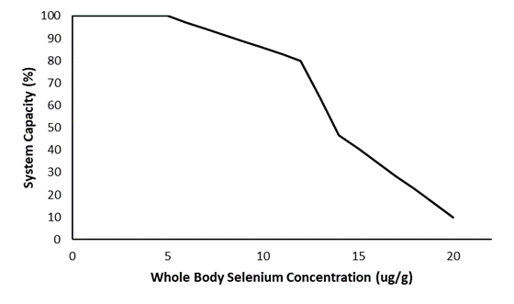
Stressor: Selenium (µg/g whole body)

Response: System Capacity (%)

Species: Westslope Cutthroat Trout

(Oncorhynchus clarkii lewisi

Life Stage: adult

System: Alberta foothills watersheds, excluding National Parks

Function Derivation: observational data, population model

Transferability of Function: This function was developed for and applied to Westslope Cutthroat Trout but was based on a population model for Yellowstone Cutthroat Trout (life history parameters measured in the Snake River). It should only be used on other subspecies of Cutthroat Trout with caution.

Model Validation: Model not validated on independent data.

Detailed SR Function Description

Derivation of the function:

Selenium is a naturally occurring element, necessary in trace amounts for metabolic processes but toxic at high concentrations (Frost and Lish 1975; Wang and Gao 2001). A variety of natural and human causes can lead to increases in selenium in fish, including open-pit mining that exposes limestone, increases in sedimentation and run-off, and atmospheric deposition from coal-burning power plants (Barceloux 1999; Lemly 2004). In salmonid fish, observed individual-level effects of selenium toxicity include a decrease in egg incubation time, hatch rate, fry survival, juvenile survival, and juvenile growth (e.g. Hodson et al. 1980, Hamilton et al. 1986, Hamilton et al. 1990). High concentrations of selenium have been detected in east slopes streams in the range of Athabasca Rainbow Trout, apparently caused by open-pit coal mining (Palace et al. 2004). Extensive reviews of selenium in Alberta fishes and waters are found in Fortin (2010) and Pilgrim (2012).

The stressor-response curve for Westslope Cutthroat Trout was derived from the demographic Yellowstone Cutthroat Trout model developed by Van Kirk and Hill (2007) which predicted population declines over time after selenium exposure but re-stabilized at a lower equilibrium population size. These equilibria decreased sigmoidally with increasing whole-body tissue selenium concentrations (Figure 1).

Although the ecotoxicology of elevated selenium levels in warm and cold-water fish has been studied by numerous authors, the effects of selenium contamination remain somewhat controversial (Kennedy et al. 2000, Sappington 2002, Hardy et al. 2010). Therefore, as new population-level literature becomes available, the dose-response curve should be updated.

Source of stressor data to apply the function:

Athabasca Rainbow Trout and Westslope Cutthroat Trout values at this time are set to 0 but it is our expectation that monitoring from industry will have taken place and whole-body tissue concentrations would be available.

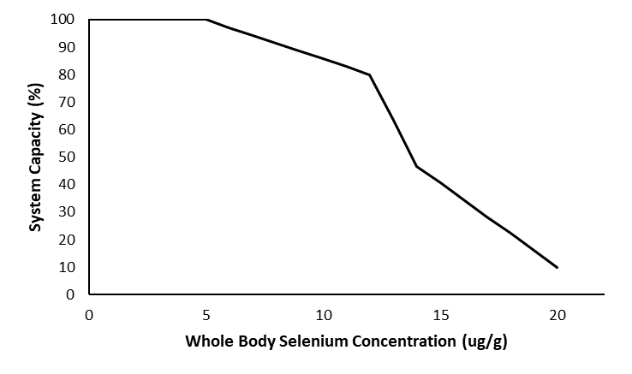
Stressor-Response Function
Figure 1: Stressor-response curve depicting the expected relationship between whole body selenium (µg/g) and the system capacity of Westslope Cutthroat Trout populations.

Stressor-Response Table
Table 1: Stressor response relationship reflecting whole body selenium concentration and the system capacity of Westslope Cutthroat Trout populations.
Selenium (µg/g tissue) | System Capacity (%) | SD | Lower Limit | Upper Limit
0 | 100 | 0 | 0 | 100
1 | 100 | 0 | 0 | 100
2 | 100 | 0 | 0 | 100
3 | 100 | 0 | 0 | 100
4 | 100 | 0 | 0 | 100
5 | 100 | 0 | 0 | 100
6 | 97.14284 | 0 | 0 | 100
7 | 94.2857 | 0 | 0 | 100
8 | 91.42856 | 0 | 0 | 100
9 | 88.57142 | 0 | 0 | 100
10 | 85.71428 | 0 | 0 | 100
11 | 82.85714 | 0 | 0 | 100
12 | 80 | 0 | 0 | 100
13 | 63.36 | 0 | 0 | 100
14 | 46.66 | 0 | 0 | 100
15 | 40.55 | 0 | 0 | 100
16 | 34.44 | 0 | 0 | 100
17 | 28.33 | 0 | 0 | 100
18 | 22.22 | 0 | 0 | 100
19 | 16.11 | 0 | 0 | 100
20 | 10 | 0 | 0 | 100

SR Function Confidence and Sources of Uncertainty
This uncertainty rubric was populated based on a summary report, not by the authors of the function with the original data. These rankings should be reassessed if additional information is available.
 | Low Confidence | Moderate Confidence | High Confidence
Data Source for SR Function |  | X
Rationale --> | The function was based on population modelling with life history parameters derived from empirical landscape studies. The population model was published (Van Kirk & Hill 2007), but not validated on natural populations.
Shape of SR Function |  | X
Rationale --> | The shape of the function is supported by a published population model, but there is uncertainty associated with lack of empirical measurements on the landscape.
Data Variance/  Consistency | X
Rationale --> | Variance around this function is largely unknown.
Applicability to System | X
Rationale --> | This source model was based on a different subspecies of Cutthroat Trout in separate watersheds.
Potential Stressor Interactions |  |  | X
Rationale --> | Interacting stressors are unlikely because the function was based on a population model specified to track the impact of selenium on natural populations.

Recommended Citation
This document should be cited as:
Government of Alberta. 2024. Selenium stressor-response function for Athabasca Rainbow Trout and Westslope Cutthroat Trout. Environment and Protected Area Native Trout Cumulative Effects Model.

_____________________________________________________________________________________________

References

Barceloux, D.G. 1999. Selenium. Clinical Toxicology 37: 145-172.
Fortin, B.L. 2010. Selenium dynamics in Canadian Rocky Mountain lakes. M.Sc. thesis, Department of Biological Sciences, University of Alberta. Edmonton, Alberta. 130 pp.
Frost, D.V., and P.M. Lish. 1975. Selenium in biology. Annual Review of Pharmacology 15: 259-284.
Hamilton, S.J., and R.H. Wiedmeyer. 1990. Concentrations of boron, molybdenum, and selenium in Chinook salmon. Transactions of the American Fisheries Society 119:500–510.
Hamilton, S.J., Palmisano, A.N., Wedemeyer, G.A., and W.T. Yasutake. 1986. Impacts of selenium on early life stages and smoltification of fall Chinook salmon. Transactions of North American Wildlife Natural Resources Conference 51:343-356.
Hardy, R.W., L.L. Oram, and G. Moller. 2010. Effects of dietary selenomethionine on cutthroat trout (Oncorhynchus clarki bouvieri) growth and reproductive performance over a life cycle. Archives of Environmental Contamination and Toxicology 58: 237-245.
Hodson, P.V., D.J. Spry, and B.R. Blunt. 1980. Effects on rainbow trout (Salmo gairdneri) of a chronic exposure to waterborne selenium. Canadian Journal Fisheries and Aquatic Science 37:233–240.
Kennedy, C.J., L.E. McDonald, R. Loveridge, and M.M. Strosher. 2000. The effect of bioaccumulated selenium on mortalities and deformities in the eggs, larvae, and fry of a wild population of cutthroat trout (Oncorhynchus clarkii lewisi). Archives of Environmental Contamination and Toxicology 39: 46-52.
Lemly A.D. 2004. Aquatic selenium pollution is a global environmental safety issue. Ecotoxicol Environ Saf. 59(1):44-56.
Palace, V.P., C. Baron, R.E. Evans, J. Holm, S. Kollar, K. Wautier, J. Werner, P. Siwik, G. Sterling, and C.F. Johnson. 2004. An assessment of the potential for selenium to impair reproduction in bull trout, Salvelinus confluentus, from an area of active coal mining. Environmental Biology of Fishes 70: 169-174.
Pilgrim, N.L. 2012. Multigenerational effects of selenium in rainbow trout, brook trout, and cutthroat trout. M.Sc. thesis, University of Lethbridge. Lethbridge, AB. 123 pp.
Sappington K.G. 2002. Development of aquatic life criteria for selenium: a regulatory perspective on critical issues and research needs. Aquatic Toxicology 57:101–113.
Van Kirk, R.W., and S.L. Hill. 2007. Demographic model predicts trout population response to selenium based on individual-level toxicity. Ecological Modelling 206:407-420.
Wang, Z., and Y. Gao, 2001. Biogeochemical cycling of selenium in Chinese environments. Applied Geochemistry 16: 1345-1351.

