# Summary: Percent Cobble and Boulder Substrate Cover and System Capacity for Nooksack Dace

# Stressor**:** % cobble and boulder substrate cover

# Response: System Capacity (%)

# Species: Nooksack Dace (*Rhinichthys cataractae*)

# Life Stage: Adult

# System: Lower Fraser Valley, including the full distribution range of Nooksack Dace

# Function Derivation: Empirical data for Nooksack Dace from Bertrand and Pepin creeks and published Habitat Suitability Index (HSI) curve for Longnose Dace from across North America

# Transferability of Function: As local adaptations are likely minimal among different Nooksack Dace populations, we would not expect much variation in true tolerance among populations. This function should therefore be broadly applicable to all populations of the species with caution.

# Model Validation: The model has not been validated on independent data for Nooksack Dace due to data unavailability.

# Detailed SR Function Description:

The final curve was based on relationship between % cobble substrate cover and Nooksack Dace density identified in Gray et al. (2024) using empirical data. We capped the maximum habitat capacity at 80% to prevent unrealistically high predicted capacity using the Gray et al. (2024) power function between dace density and % cobble. (see Fig. below). The habitat suitability curve for Longnose Dace (Edward et al., 1983) also generally supports a positive association between % cobble cover and system capacity. Note that while there is a generally positive overall relationship between cobble substrate and dace density, the variance around the line is large, particularly at higher cobble substrate cover. While we can be reasonably confident that dace abundance increases up to 20-40% cobble cover, it could also be reasonable to assume that it plateaus above this level as implied by the Edwards et al. (1983) curve for Longnose dace. At the expert elicitation workshop held in November 2024, John Gray indicated that Dace may even prefer larger substrate (i.e. boulder) and that a SR for boulder would be similar to the one for cobble. Therefore, for the x-axis of this SR function %cobble and boulder combined is more appropriate for more general application to streams/reaches that actually have boulder-sized substrate present.

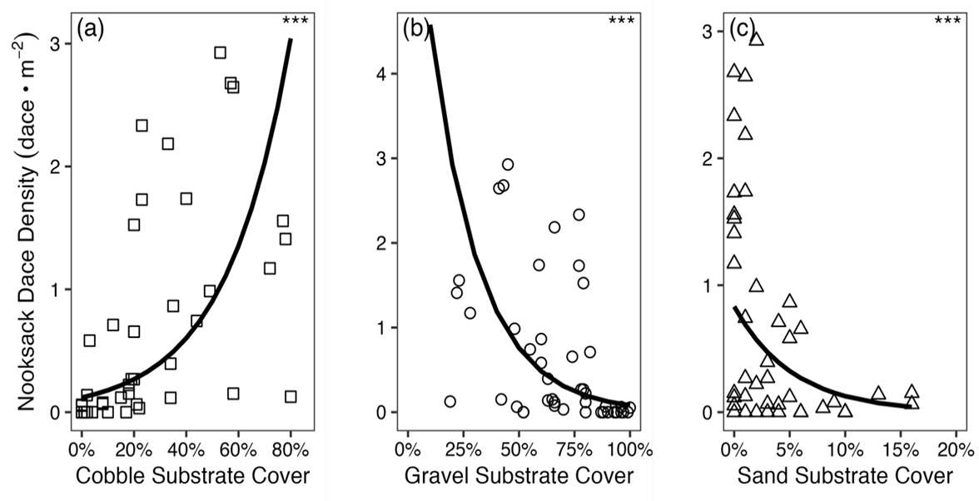

**Figure 1:** Nooksack Dace density-substrate relationships from Gray and Rosenfeld (2024).

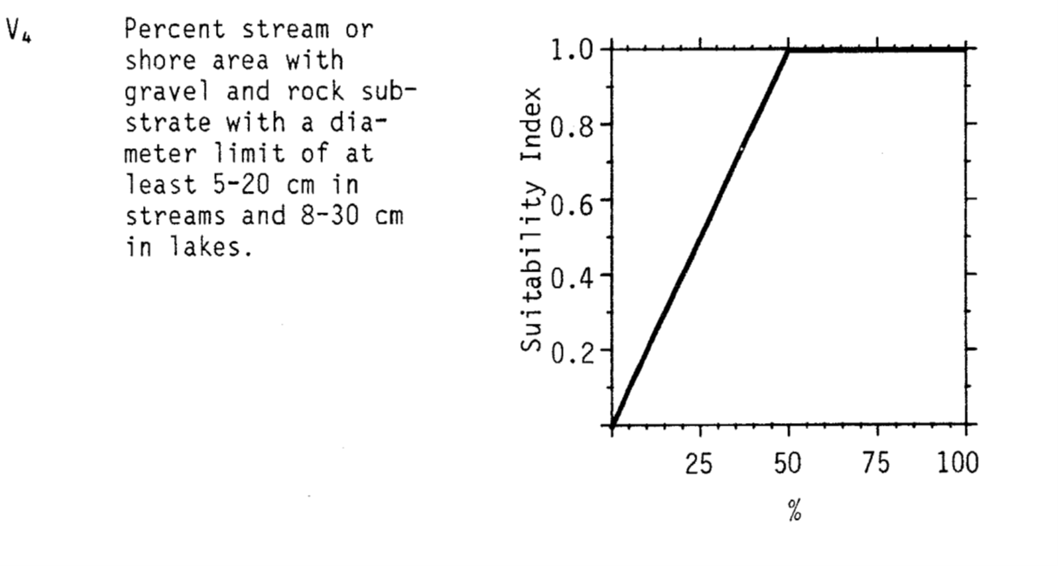

**Figure 2:** Nooksack Dace density-substrate relationships from Edwards et al. (1983).

## Source of stressor data to apply the function:

Percent cobble substrate data is available for most (but not all) reaches in Bertrand, Pepin, Fishtrap Creeks, and the Salmon River, collected as part of Pearson (2004) and subsequent field work to define critical habitat for Nooksack dace.

# Stressor-Response Function

**Figure 3:** Stressor-response curve depicting the expected relationship between Percent cobble substrate cover and the system capacity of Nooksack Dace.

Stressor-Response Table

**Table 1:** Stressor response relationship reflecting percent cobble substrate cover and the system capacity of Nooksack Dace populations.

|  |  |  |  |  |
| --- | --- | --- | --- | --- |
| **Percent cobble substrate cover** | **System Capacity (%)** | **SD** | **Lower Limit** | **Upper Limit** |
| 3.00 | 0.00 | 0 | 0 | 100 |
| 13.00 | 4.50 | 0 | 0 | 100 |
| 29.00 | 12.73 | 0 | 0 | 100 |
| 42.00 | 22.13 | 0 | 0 | 100 |
| 53.50 | 35.07 | 0 | 0 | 100 |
| 62.00 | 49.06 | 0 | 0 | 100 |
| 69.00 | 64.80 | 0 | 0 | 100 |
| 75.00 | 83.33 | 0 | 0 | 100 |
| 80.00 | 100.00 | 0 | 0 | 100 |

# SR Function Confidence and Sources of Uncertainty

The uncertainty assessment below is based on our evaluation of the available data and level of confidence in the derived function. These rankings should be reassessed if additional information becomes available.

|  |  |  |  |
| --- | --- | --- | --- |
|  | **Low Confidence** | **Moderate Confidence** | **High Confidence** |
| **Data Source for SR Function** |  |  | **X** |
| Rationale --> | This function is based on data for Nooksack Dace from target system. | | |
| **Shape of SR Function** |  | **X** |  |
| Rationale --> | There is only a moderate confidence in shape of the function due to high variability in data, .i.e. while we are confident that increased cobble results in increased dace abundance, the function may plateau before 80% cobble (i.e. highest density according to the best fit power function) | | |
| **Data Variance/**  **Consistency** |  | **X** |  |
| Rationale --> | Variance around this function is considerable. | | |
| **Applicability to System** |  |  | **X** |
| Rationale --> | Data from the target system (same species, populations and geographic area) was used to generate the function. | | |
| **Potential Stressor Interactions** |  |  | **X** |
| Rationale --> | A positive correlation is expected between percent cobble substrate cover and percent riffle area in the reach as both can be influenced by stream gradient. Percent cobble substrate cover influences Nooksack Dace directly through creation of interstitial habitat. A stressor-response function has been derived for the effect of percent riffle in a reach on system capacity of Nooksack Dace; however, this function can be considered independent, since the % riffle function reflects lack of use of isolated riffles at low population size. Similarly, while increased riffle area in a reach will result in increased Nooksack dace abundance, the quality of the riffle (i.e. density of dace present) will be an independent function of substate type in any particular riffle. | | |

# Recommended Citation

This document should be cited as:

Usoof, A.M. and Rosenfeld, J.S. 2024. Relationship between system capacity and Percent Cobble Substrate Cover for Nooksack Dace.

**_____________________________________________________________________________________________**

# References

Gray, J., J. Rosenfeld, M. Pearson, K. Colletti, and J. Ross. 2024. The effect of riffle restoration on the recovery of endangered Nooksack Dace (Rhinichthys cataractae sp. cataractae). Facets 9:1–15.