# Summary: Length of continuous deep pool (>70 cm depth) and System Capacity for Salish Sucker

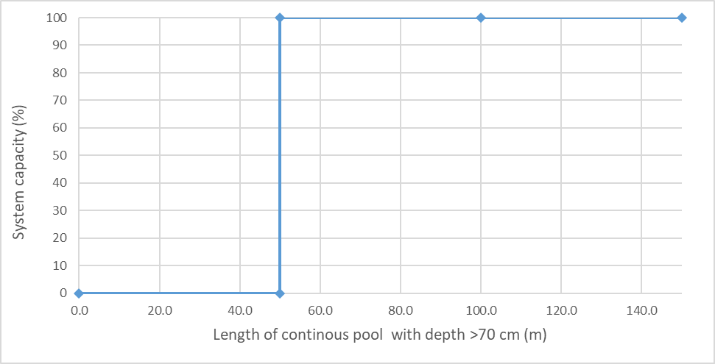

# Stressor**:** Length of continuous pool > 70 cm depth

# (m)

# Response: System Capacity (%)

# Species: Salish Sucker (*Catostomus sp.*)

# Life Stage: Adult and Juvenile

# System: Lower Fraser Valley, including the full distribution range of Salish Sucker

# Function Derivation: Empirical data for Salish Sucker from lower Fraser Valley

# 

# Transferability of Function: As local adaptations are likely minimal among different Salish Sucker populations, we would not expect much variation in true tolerance among populations. This function should therefore be broadly applicable to all populations of the species.

# Model Validation: The model is not validated on independent data for Salish Sucker due to unavailability of data.

# Detailed SR Function Description:

We inferred a stepwise response with a threshold value of 50 m continuous pool length above 70 cm water depth based on the inferences made in Pearson (2004) and Fisheries and Oceans Canada (2019) i.e., a minimum of 50 m continuous pool with a water depth exceeding 70 cm under summer low flow conditions is required to support moderate to high densities of juvenile and adult Salish Sucker. See also the associated Salish Sucker SR function for habitat depth.

Figure 1. Relationship between water depth (cm) and CPUE of YOY (top) and adult (bottom) Salish Sucker (Pearson, 2004)

## Source of stressor data to apply the function:

# Data on length of reaches greater than 70cm deep is available for most (but not all) reaches in Bertrand, Pepin, Fishtrap Creeks, and the Salmon River, collected as part of Pearson (2004) and subsequent field work to define critical habitat for Salish sucker.

# Stressor-Response Function

**Figure 1:** Stressor-response curve depicting the expected relationship between mean water depth (cm) and the system capacity of Salish Sucker.

Stressor-Response Table

**Table 1:** Stressor response relationship reflecting mean water depth (cm) and the system capacity of Salish Sucker populations.

|  |  |  |  |  |
| --- | --- | --- | --- | --- |
| **Length of continuous pool >70 cm (m)** | **Mean System Capacity (%)** | **SD** | **Lower Limit** | **Upper Limit** |
| 0.0 | 0 | 0 | 0 | 100 |
| 49.9 | 0 | 0 | 0 | 100 |
| 50.0 | 100 | 0 | 0 | 100 |
| 100.0 | 100 | 0 | 0 | 100 |
| 150.0 | 100 | 0 | 0 | 100 |

# SR Function Confidence and Sources of Uncertainty

The uncertainty assessment below is based on our evaluation of the available data and level of confidence in the derived function. These rankings should be reassessed if additional information becomes available.

|  |  |  |  |
| --- | --- | --- | --- |
|  | **Low Confidence** | **Moderate Confidence** | **High Confidence** |
| **Data Source for SR Function** |  |  | **X** |
| Rationale --> | This function is based on data for Salish Sucker from target system. | | |
| **Shape of SR Function** |  |  | **X** |
| Rationale --> | The relationship has been established for the target species and system based on empirical data. | | |
| **Data Variance/**  **Consistency** | **X** |  |  |
| Rationale --> | Variance around this function is likely large, but based on Fig. 3.3 in Pearson (2024) above, there can be fairly high confidence that adult sucker are not caught at high abundance in shallow water; and the threshold depth of ~70cm is likely reasonably robust). | | |
| **Applicability to System** |  |  | **X** |
| Rationale --> | Data from the target system (same species, populations and geographic area) was used to generate the function. | | |
| **Potential Stressor Interactions** |  |  | **X** |
| Rationale --> | Deep pool habitats can produce hypoxic conditions (decline in Dissolved Oxygen concentration in the water), which also influence Salish Sucker directly (Rosenfeld et al. 2021). However, a stressor-response function has been derived for the effect of Dissolved Oxygen concentration on system capacity of Salish Sucker. Nevertheless, estimation of Dissolved Oxygen at the reach scale for populating the Stressor Magnitude file for CEMPRA modelling will need to account for habitat (i.e. deep pool) effects on hypoxia. | | |

Recommended Citation

This document should be cited as:

Usoof, A.M. and Rosenfeld, J.S. 2024. Relationship between system capacity and length of continuous deep pool for Salish Sucker.

**_____________________________________________________________________________________________**

# References

Fisheries and Oceans Canada. 2019. Recovery strategy for the Salish Sucker ( Catostomus sp .) in Canada [Proposed]. 1st amendment. Species at Risk Act Recovery Strategy Series. Fisheries and Oceans Canada, Ottawa.

Rosenfeld, J., M. P. Pearson, J. Miners, and K. Zinn. 2021. Effects of landscape-scale hypoxia on Salish sucker and salmonid habitat associations : implications for endangered 1233:1219–1233.