Summary: Percent Cobble and Boulder Substrate Cover and System Capacity for Nooksack Dace

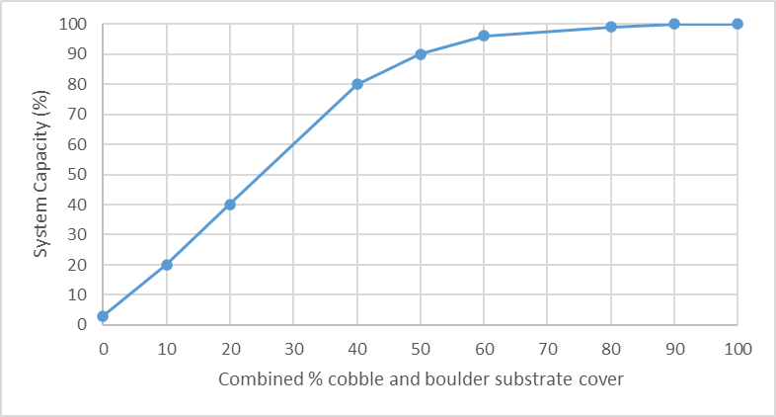
Stressor: % cobble and boulder substrate cover

Response: System Capacity (%)

Species: Nooksack Dace (Rhinichthys cataractae)

Life Stage: Adult

System: Lower Fraser Valley, including the full distribution range of Nooksack Dace

Function Derivation: Empirical data for Nooksack Dace from Bertrand and Pepin creeks and published Habitat Suitability Index (HSI) curve for Longnose Dace from across North America

Transferability of Function: As local adaptations are likely minimal among different Nooksack Dace populations, we would not expect much variation in true tolerance among populations. This function should therefore be broadly applicable to all populations of the species with caution.

Model Validation: The model has not been validated on independent data for Nooksack Dace due to data unavailability.

Detailed SR Function Description:
The final curve is largely based on the relationship between % cobble substrate cover and Nooksack Dace density identified in Gray et al. (2024) using empirical data (Fig. 1a below), supported by the habitat suitability curve for Longnose Dace (Edwards et al. 1983; Fig. 2), which also generally supports a positive association between % cobble cover and system capacity. However, we modified the density vs. % cobble curve from Gray et al. (2024) to increase the initial slope to make it closer to the Edwards et al. (1983) Longnose Dace curve. This was because almost no dace critical habitat reaches have the 80% cobble in riffle habitat required to achieve 100% capacity as predicted by the Gray et al. (2024) function (Fig. 1a). Even the best Bertrand Ck. high-density Nooksack Dace habitat (which we are using as the reference benchmark for 100% capacity) is in the range of 50-60% cobble cover, which is not consistent with the Gray et al. 2024 function, since we assume that high-density Bertrand Creek reaches represent a reference condition of 100% capacity. The final curve parameterization closer to the Edwards et al. curve ensures that current maximum dace densities are consistent with upper model predictions, while still allowing for increased cobble abundance to incrementally improve habitat. Note the large scatter of data in Gray et al. (2024) Figure 1a relationship broadly overlaps with both the fitted Gray et al. curve and the final SR function relationship. In addition, at the expert elicitation workshop held in November 2024, John Gray indicated that Dace may even prefer larger substrate (i.e. boulder) and that a SR function for boulder would be similar to the one for cobble. Therefore, for the x-axis of this SR function %cobble and boulder combined is more appropriate for more general application to streams/reaches that actually may have boulder-sized substrate present.
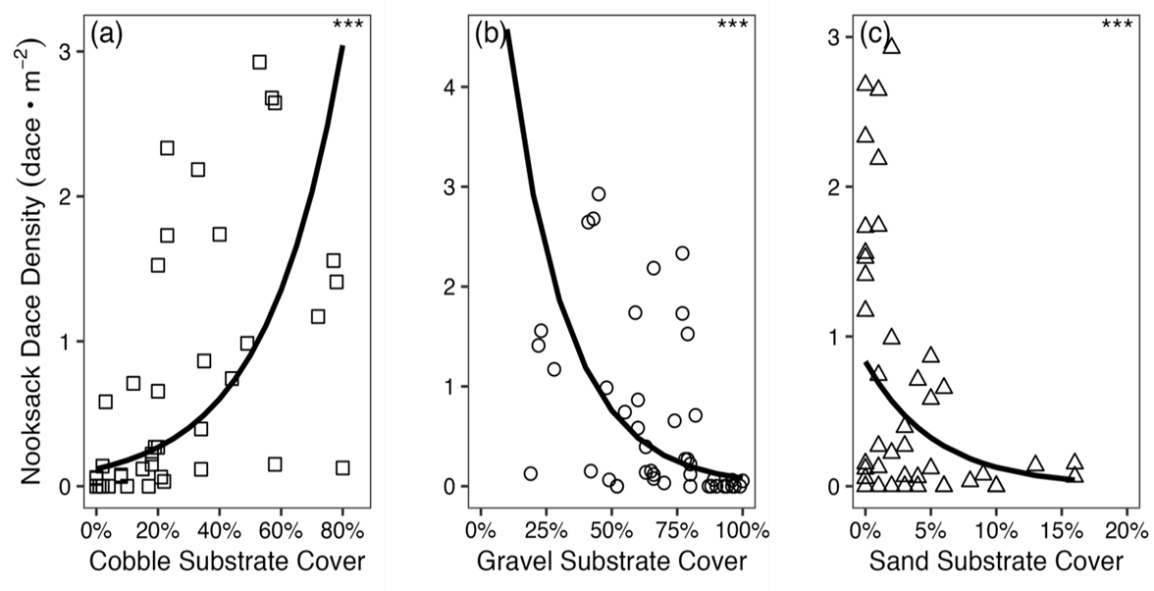
Figure 1: Nooksack Dace density-substrate relationships from Gray and Rosenfeld (2024).
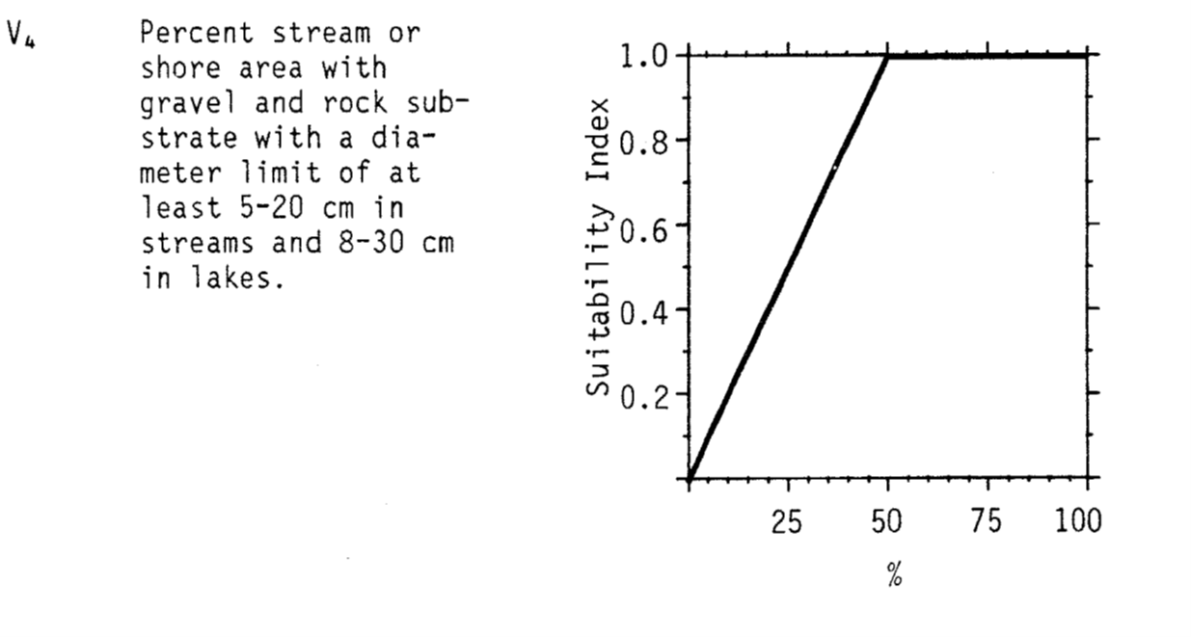
Figure 2: Nooksack Dace density-substrate relationships from Edwards et al. (1983).

Source of stressor data to apply the function:
Percent cobble substrate data is available for most (but not all) reaches in Bertrand, Pepin, and Fishtrap Creeks, collected as part of Pearson (2004) and subsequent field work to define critical habitat for Nooksack dace.

Stressor-Response Function

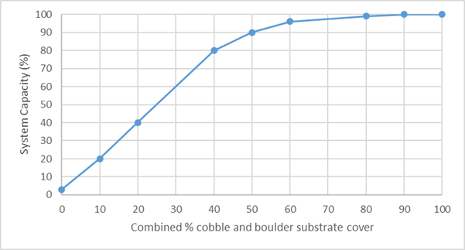
Figure 3: Stressor-response curve depicting the expected relationship between Percent cobble substrate cover and the system capacity of Nooksack Dace.

Stressor-Response Table
Table 1: Stressor response relationship reflecting percent cobble substrate cover and the system capacity of Nooksack Dace populations.
Percent cobble substrate cover | System Capacity (%) | SD | Lower Limit | Upper Limit
0 | 3 | 0 | 0 | 100
10 | 20 | 0 | 0 | 100
20 | 40 | 0 | 0 | 100
40 | 80 | 0 | 0 | 100
50 | 90 | 0 | 0 | 100
60 | 96 | 0 | 0 | 100
80 | 99 | 0 | 0 | 100
90 | 100 | 0 | 0 | 100
100 | 100 | 0 | 0 | 100

SR Function Confidence and Sources of Uncertainty
The uncertainty assessment below is based on our evaluation of the available data and level of confidence in the derived function. These rankings should be reassessed if additional information becomes available.

 | Low Confidence | Moderate Confidence | High Confidence
Data Source for SR Function |  |  | X
Rationale --> | This function is based on data for Nooksack Dace from target system.
Shape of SR Function |  | X
Rationale --> | There is only a moderate confidence in shape of the function due to high variability in data, .i.e. while we are confident that increased cobble results in increased dace abundance, the function may plateau before 80% cobble (i.e. highest density according to the best fit power function)
Data Variance/  Consistency |  | X
Rationale --> | Variance around this function is considerable.
Applicability to System |  |  | X
Rationale --> | Data from the target system (same species, populations and geographic area) was used to generate the function.
Potential Stressor Interactions |  |  | X
Rationale --> | A positive correlation is expected between percent cobble substrate cover and percent riffle area in the reach as both can be influenced by stream gradient. Percent cobble substrate cover influences Nooksack Dace directly through creation of interstitial habitat. A stressor-response function has been derived for the effect of percent riffle in a reach on system capacity of Nooksack Dace; however, this function can be considered independent, since the % riffle function reflects lack of use of isolated riffles at low population size. Similarly, while increased riffle area in a reach will result in increased Nooksack dace abundance, the quality of the riffle (i.e. density of dace present) will be an independent function of substate type in any particular riffle.

Recommended Citation
This document should be cited as:
Usoof, A.M. and Rosenfeld, J.S. 2024. Relationship between system capacity and Percent Cobble Substrate Cover for Nooksack Dace.
_____________________________________________________________________________________________

References

Edwards, E.A., Hiram L., and Schreck, C.B. 1983. Habitat Suitability Index Models: Longnose dace. US Geologic Survey, FWS/OBS 82/10.33
Gray, J., J. Rosenfeld, M. Pearson, K. Colletti, and J. Ross. 2024. The effect of riffle restoration on the recovery of endangered Nooksack Dace (Rhinichthys cataractae sp. cataractae). Facets 9:1–15.

