Summary: Percent Riffle in Reach and System Capacity for Nooksack Dace

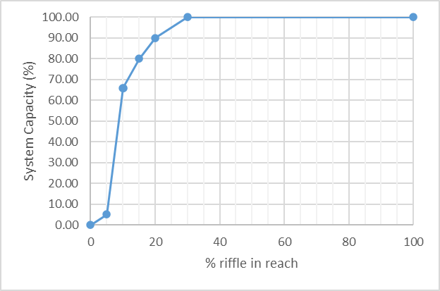
Stressor: % riffle in reach

Response: System Capacity (%)

Species: Nooksack Dace (Rhinichthys cataractae)

Life Stage: Adult

System: Lower Fraser Valley, including the full distribution range of Nooksack Dace

Function Derivation: Empirical data for Nooksack Dace from Bertrand Creek and for Longnose Dace from across North America.

Transferability of Function: As local adaptations are likely minimal among different Nooksack Dace populations, we would not expect much variation in true tolerance among populations. This function should therefore be broadly applicable to all populations of the species with caution.

Model Validation: The model has not been validated on independent data for Nooksack Dace due to data unavailability.

Detailed SR Function Description:
The shape and threshold for the final curve is based on Pearson et al. (2007) and Pearson (2004), which shows a large decline in percent reaches occupied by Nooksack Dace when the percent riffle in a reach in below 5-10% (Figure 1). The definition of Critical Habitat for Nooksack Dace includes reaches that are greater than 10% riffle, because reaches with less than 10% riffle tend to have lower riffle occupancy, presumably because the less hospitable habitat between riffles (i.e., low suitability pool habitat) reduces the likelihood of the overall reach supporting a local dace population. Occupancy drops noticeably at 5% riffle, and then approaches zero occupancy at 0% riffle (see Fig. 2 below). However, the logic that reaches above 10% riffle have equivalent habitat capacity - implicit in the plateau at a habitat suitability of 1 in the Edwards et al. (1983) habitat suitability curve (Fig. 2), and Pearson 2007 (Fig. 1) is flawed. Logically, the abundance of dace should be directly proportional to riffle area in a reach (i.e. % riffle), all else being equal. This means that there should be a linear relationships between % riffle and habitat capacity, i.e. a direct 1:1 relationship, rather than the direct implication of the Edwards et al. line that dace abundance is equal in reaches ranging from 25-80% riffle, which is somewhat nonsensical.
The SR function has therefore been altered so that habitat capacity (relative dace abundance) is zero at 0% riffle, increases steeply from 5% to 10% riffle at the reach scale, and then at a reduced rate at higher riffle abundance until it plateaus at 100% capacity at 30% riffle. 100% capacity (the plateau breakpoint) was not set at 80% or 100% riffle because the low gradient of most Nooksack Dace reaches (aside from in the Brunette River) means that achieving more than 25-30% riffle would be geomorphically impossible. In addition, the highest reference densities of dace occur in Bertrand Creek which has a maximum % riffle in the range of 30%; setting 100% capacity at 30% riffle therefor ensures that current maximum capacity will be achieved in the reaches with maximum possible % riffle. This is broadly realistic, because some reaches in Bertrand creek with ~15% riffle currently support healthy populations of dace, and the steep slope between 5-15% riffle will allow for rapidly increased carrying capacity over this range. While the curve allows for increase capacity at a higher proportion of riffle habitat up to 30%, the incremental benefits are likely lower. NOTE, however, that this SR function only applies to "Joe" model applications with relative habitat capacity where the reference state is set at 100% capacity (in this case, corresponding to 30% riffle). If dace abundance is being directly estimated based on the product of maximum density and wetted area of the reach, then the relationship between % riffle habitat and habitat capacity (or population size) should be treated as linear in direct calculation of population abundance.

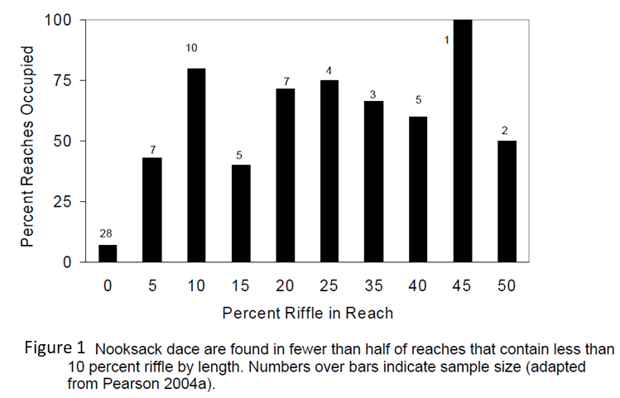

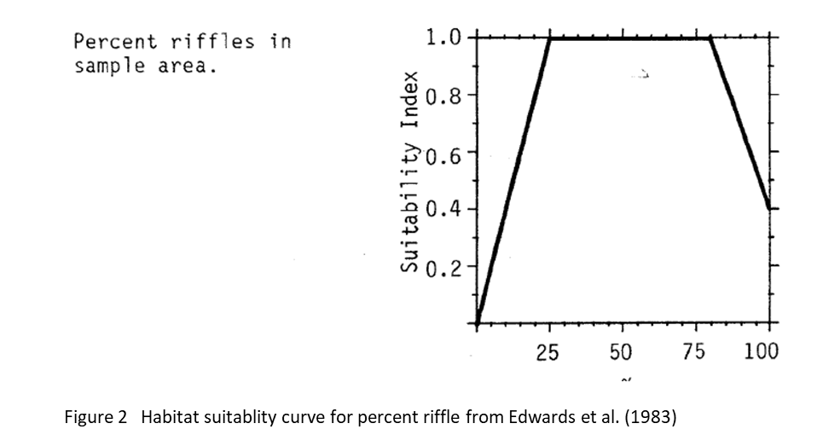

Source of stressor data to apply the function:

Percent riffle data is available for most (but not all) reaches in Bertrand, Pepin, and Fishtrap Creeks, collected as part of Pearson (2004) and subsequent field work to define critical habitat for Nooksack dace.

Stressor-Response Function

Figure 3. Stressor-response curve depicting the expected relationship between Percent Riffle in Reach and the system capacity of Nooksack Dace.
Stressor-Response Table
Table 1: Stressor response relationship reflecting Dissolved Oxygen concentration (mg/L) and the system capacity of Nooksack Dace populations.
Percent Riffle in Reach | System Capacity (%) | SD | Lower Limit | Upper Limit
0.00 | 0.00 | 0 | 0 | 100
5 | 5 | 0 | 0 | 100
10.00 | 66.00 | 0 | 0 | 100
10.1 | 66.00 | 0 | 0 | 100
15.00 | 80.00 | 0 | 0 | 100
20.00 | 90.00 | 0 | 0 | 100
30.00 | 100.00 | 0 | 0 | 100
100 | 100 | 0 | 0 | 100

SR Function Confidence and Sources of Uncertainty
The uncertainty assessment below is based on our evaluation of the available data and level of confidence in the derived function. These rankings should be reassessed if additional information becomes available.
 | Low Confidence | Moderate Confidence | High Confidence
Data Source for SR Function |  |  | X
Rationale --> | This function is based on data for Nooksack Dace from target system.
Shape of SR Function |  |  | X
Rationale --> | The relationship has been established for the target species and system based on empirical data.
Data Variance/  Consistency |  | X
Rationale --> | Variance around this function is unknown, but the patterns appears fairly consistent for both Nooksack dace and Longnose dace.
Applicability to System |  |  | X
Rationale --> | Data from the target system (same species, populations and geographic area) was used to generate the function.
Potential Stressor Interactions |  |  | X
Rationale --> | Percent riffle in a reach can influence temperature (shallow water may warm more quickly), and Dissolved Oxygen concentration in the water (riffles are sites of re-aeration), which both influence Nooksack Dace physiology. However, separate stressor-response functions have been derived for the effects of temperature and Dissolved Oxygen concentration on system capacity for Nooksack Dace. In addition, substrate type may also be correlated with percent riffle, since both increase with higher gradient, and both influence system capacity. However, substrate size may also act independently of percent riffle, because riffles that are primarily gravel have lower abundance of Nooksack dace. Nevertheless, a separate stressor-response function has been derived for the effect of cobble substrate cover.

Recommended Citation
This document should be cited as:
Usoof, A.M. and Rosenfeld, J.S. 2024. Relationship between system capacity and Percent Riffle in Reach for Nooksack Dace.
_____________________________________________________________________________________________

References
Edwards, E. A., H. Li, and C. B. Schreck. 1983. Habitat Suitability Index Models: Longnose Dace. U.S. Dept. Int., FishWildl. Serv. FWS/OBS-82/10.33.
Pearson, M. P. 2004. The ecology, status and recovery prospects of Noonsack dace (Rhinichthys Cataractae ssp.) and Salish sucker (Catostomus sp.) in Canada. University of British Columbia.
Pearson, M. P., T. Hatfield, J. D. McPhail, J. S. Richardson, J. S. Rosenfeld, H. Schreier, D. Schluter, D. J. Sneep, M. Stejpovic, E. B. Taylor, and P. M. Wood. 2007. Recovery Strategy for the Nooksack Dace ( Rhinichthys cataractae) in Canada. Species at. Fisheries and Oceans Canada, Vancouver B.C.

