Summary: Mean Annual Discharge and System Capacity for All Species

Stressor: Percentage of mean annual discharge (MAD; %)

Response: Mean habitat capacity (%)

Species: Nine species of Salmonids. (Chinook, Atlantic, Rainbow trout (steelhead), Brown trout, Brook trout, Pink, European grayling, Cutthroat, Coho)

System: Multiple freshwater rivers, creeks, and streams. 14 studies originate from Canada (BC and NB), 13 studies from the USA (Washington, Idaho, Alaska, Colorado, California, Michigan), four from Europe (Belgium, Finland, Norway), and one from New Zealand.

Function Derivation: data from 28 observational studies and 7 experimental studies.

Transferability: Broadly transferable across a wide range of flows ranging from 0.4 to 750 m³/s. Relationship controls for the effects of seasonal hydrology. and is derived from 6 from migration/spawning flow, 7 from summer high rearing flow, 15 from summer low rearing flow, 7 from winter low rearing flows. Best applied with flow metrics that are monthly.

Model validation: Model has not been validated on independent data.

Detailed SR Function Description

Derivation of the function: Rosenfeld & Enbright (2024) compile data from 35 flow-ecology relationships related to salmonid productive capacity. Stress response function was controlled for seasonal hydrology (summer low flows, summer high flows, migration/spawning flows, winter low flows).

Ecological response was normalized across studies to make them comparable. Original responses include abundance, fish density, survival, biomass, smolt production, catch per unit effort, growth, redd abundance, and egg survival. To normalize and rescale each ecological response, each value was scaled by the maximum ecological response observed in each study such that mean habitat capacity percentage (normalized response) = response / maximum ecological response observed for a given study (which occurs at ~56% MAD, see SR figure).

Source of stressor data to apply the function:

Percentage of mean annual discharge (%MAD) data is derived from credible sources, either from source study, the Water Survey of Canada, or the U.S. Geological Survey. Engage Digitizer software was also used to extract flow data from published figures when available. Data was standardized by dividing absolute flow by MAD to achieve %MAD values (see Rosenfeld & Enright 2024). Such standardization allows for comparison of flow metrics across a wide range of stream sizes (see Rosenfeld et al. 2017). See Table S1 in Rosenfeld & Enright 2024 for specific stressor data, data source, and river system. doi.org/10.1093/tafafs/vnaf001

Stressor-Response Function

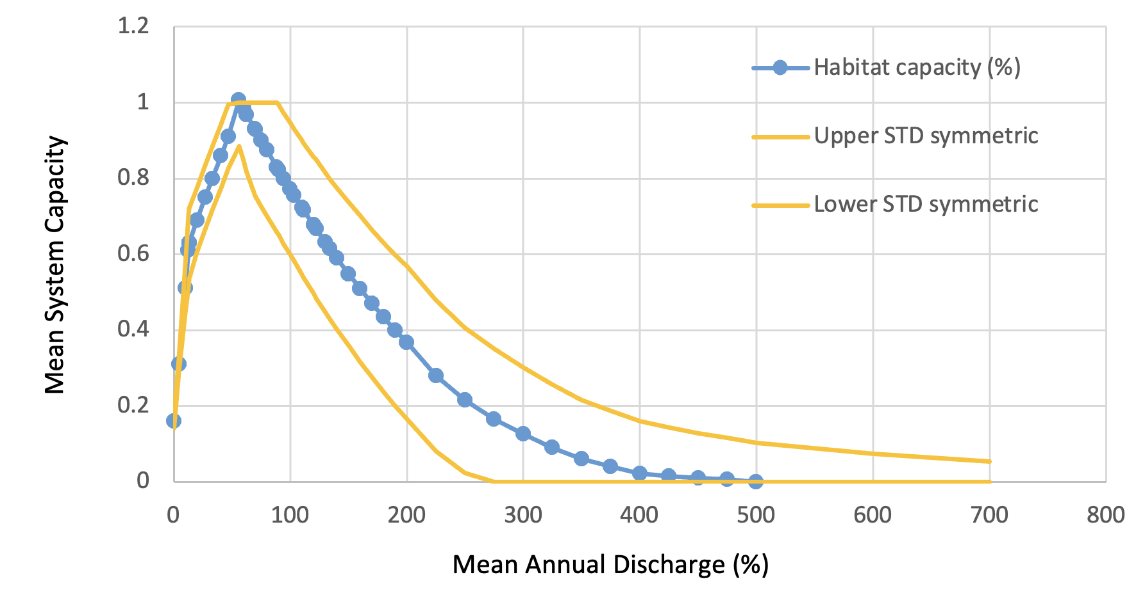

Stressor-Response Table

Mean Annual Discharge (%) | Mean System  Capacity (%) | SD | Lower Limit | Upper Limit
0 | 0.16 | 0.01786 | 0.13 | 0.2
4.52 | 0.31 | 0.01786 | 0.27 | 0.34
10 | 0.51 | 0.06378 | 0.39 | 0.64
12.58 | 0.61 | 0.09694 | 0.43 | 0.81
13.23 | 0.63 | 0.09184 | 0.45 | 0.81
13.55 | 0.63 | 0.08929 | 0.47 | 0.82
20 | 0.69 | 0.08418 | 0.53 | 0.86
27.1 | 0.75 | 0.08418 | 0.59 | 0.92
33.23 | 0.8 | 0.08418 | 0.64 | 0.97
40.65 | 0.86 | 0.08418 | 0.7 | 1.03
46.77 | 0.91 | 0.08418 | 0.76 | 1.09
56 | 1.006927099 | 0.12245 | 0.7 | 1.18
60 | 0.984098123 | 0.13776 | 0.68 | 1.22
62.26 | 0.968 | 0.14796 | 0.67 | 1.25
69.68 | 0.93 | 0.17602 | 0.64 | 1.33
70 | 0.928342013 | 0.17347 | 0.64 | 1.32
74.84 | 0.9 | 0.17347 | 0.61 | 1.29
80 | 0.874453815 | 0.17347 | 0.58 | 1.26
88.39 | 0.829 | 0.17092 | 0.54 | 1.21
90 | 0.822417598 | 0.17092 | 0.53 | 1.2
94.19 | 0.8 | 0.17219 | 0.51 | 1.185
100 | 0.772217149 | 0.17347 | 0.48 | 1.16
103.23 | 0.755 | 0.17347 | 0.47 | 1.15
110 | 0.723835956 | 0.1773 | 0.43 | 1.125
111.29 | 0.7168 | 0.17653 | 0.428 | 1.12
120 | 0.6772572 | 0.1801 | 0.38 | 1.08
122.26 | 0.66687 | 0.1824 | 0.365 | 1.075
130 | 0.632463735 | 0.18367 | 0.33 | 1.05
133.87 | 0.615 | 0.18495 | 0.315 | 1.04
140 | 0.589438075 | 0.18622 | 0.29 | 1.02
150 | 0.548162375 | 0.18878 | 0.25 | 0.985
160 | 0.508618412 | 0.1926 | 0.21 | 0.96
170 | 0.470787568 | 0.19388 | 0.18 | 0.94
180 | 0.434650801 | 0.19643 | 0.15 | 0.92
190 | 0.400188627 | 0.19898 | 0.12 | 0.9
200 | 0.367381088 | 0.20153 | 0.09 | 0.88
225 | 0.28 | 0.19872 | 0.051 | 0.83
250 | 0.215 | 0.19184 | 0.028 | 0.78
275 | 0.165 | 0.18495 | 0.01 | 0.735
300 | 0.125512713 | 0.17602 | 0 | 0.69
325 | 0.09 | 0.16582 |  | 0.65
350 | 0.06 | 0.15561 |  | 0.61
375 | 0.04 | 0.14668 |  | 0.575
400 | 0.021844698 | 0.13776 |  | 0.54
425 | 0.015 | 0.12819 |  | 0.5025
450 | 0.01 | 0.11862 |  | 0.465
475 | 0.006 | 0.10969 |  | 0.43
500 | 0 | 0.10204 |  | 0.4
600 |  | 0.07398 |  | 0.29
700 |  | 0.05357 |  | 0.21

SR Function Confidence and Sources of Uncertainty
The table below outlines criteria for assessing confidence in the SR function. NOTE: These criteria serve as guidance for raking confidence in different aspects of the SR function but are not meant to be rigidly prescriptive. Not all criteria will be applicable, and authors should use their discretion in adding additional criteria, provided they maintain clarity and transparency in the information used for assessing confidence.

 | Confidence |  |  | Rational
 | Low | Mod. | High | Rational
Data source of SR function¹ |  |  | x | Data is collected from 35 high quality data entries. Source data is a mix of observational and experimental data. However, there is some risk of publication bias if only large responses are published.
Shape of SR function² |  |  | x | The relationship is well supported and thoroughly documented in Rosenfeld & Enright 2024.
Data variance of SR function³ |  |  | x | There is spread around the SR function.
Applicability to system⁴ |  |  | x | The system is highly applicable to Salmonids. Geographic area captured is wide
Potential Stressor Interactions⁵ |  |  | x | Effects are largely independent of other variables. Seasonal hydrology is accounted for in SR function.
¹ Evaluate confidence based on the precision, accuracy, quantity, and appropriateness of data used to build the SR function. Identify the origin of the function and associated data as professional opinion, consultation workshops, mechanistic/theory- based relationships, empirical studies, field sampling, or an alternative. Specify if peer-review was conducted and provide brief citations.

² Assess confidence that the shape of the SR function is accurate (linear/non-linear; slope, inflections, intercepts, endpoints, midpoints, thresholds)

³ Is there significant variance (spread) in the data around the function? Do all data sources show consistent patterns?

⁴ How well-matched are the source data and the target system? Are they the same species, watershed, season, life stage, etc.?

⁵ Is there potential for other unaccounted variables to interact with the stressor and influence the shape of the SR function? Which stressors are likely to covary with the stressor in a biologically meaningful way?

Recommended Citation

Rosenfeld, J. 2023. Mean Annual Discharge and System Capacity for all salmonids. AEP CEMPRA Model for all salmonids.

References
Rosenfeld, Jordan S. "Developing flow–ecology relationships: Implications of nonlinear biological responses for water management." Freshwater Biology 62, no. 8 (2017): 1305-1324.

Rosenfeld, Jordan S., and Daniel Enright. "Developing generalized flow ecology relationships for stream salmonids: Providing a clearer empirical basis for minimum flow regulations." Transactions of the American Fisheries Society 154, no. 2 (2025): 162-178.

